Erie Marsh Coastal Restoration
(Michigan)

Project: This restoration project will ultimately restore 946 acres of freshwater coastal wetland in Erie Marsh Preserve, which will:
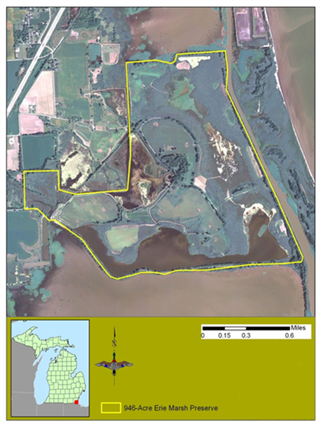
North Maumee Bay
- Allow the exchange of water, energy, and animals between targeted wetlands and Lake Erie
- Provide access to key spawning areas for ecologically and economically important fish species
- Improve function and quality of wetlands for migratory birds
- Increase capacity for wetland management and access for recreation

Link to overarching WLEB strategies:
- Implement innovative and resilient on-the-ground habitat restoration projects
- Integrate ecological and human well-being values to create a shared vision, engaging a broad spectrum of public and private interests
TNC’s Erie Marsh Preserve showing the location of the 946 acres of coastal wetlands that will be restored and enhanced by this project.

- Direct restoration investments and inform management decisions

Project summary: Erie Marsh Preserve represents 11% of the remaining marshland in southeast Michigan and is one of the largest marshes on Lake Erie. The Preserve is located along the Mississippi Flyway, a major migration corridor and stopover site for waterfowl, shorebirds, wading birds, Neotropical songbirds, and raptors. Despite all of the wildlife benefits associated with this property, it is in a highly degraded condition and in need of restoration to achieve its maximum value to natural and human communities.
Implementation of a four-phase restoration design will allow management of a mosaic of wetland types, including emergent marsh, lakeplain wet prairie, seasonally flooded moist soil wetlands, and deep water marsh, while at the same time providing effective control of invasive species. The improvements from this project will encourage visitor use for wildlife viewing and education. A proposed levee system will accommodate construction of future trails or boardwalks, viewing platforms, and educational kiosks.
Phase I: Install a new bi-directional pump station, fish passage structure and water distribution canal to reconnect the 946 wetland acres located within the perimeter levee to Lake Erie and connect the pump station to the ten independently managed wetland units.
Phase II: Construct levees to restore and enhance five independently managed wetland units.
Phase III: Construct levees, extend the water distribution canal, and install water control structure to restore and enhance two independently managed wetland units.
Phase IV: Construct levees, extend the water distribution canal, and install water control structures to restore and enhance two independently managed wetland units.
Monitoring and Management during Phases I-IV will include management of invasive species using chemical treatments and prescribed fire and monitoring changes to plants, wildlife, and fish to demonstrate project success.
Key partners:
- Erie Shooting and Fishing Club
- Ducks Unlimited
- U.S. Fish and Wildlife Service - Detroit River International Wildlife Refuge
- Michigan Department of Environmental Quality
- NOAA
- National Fish and Wildlife Foundation

Project timeframe: All phases complete by 2017
Phase I: Anticipated completion summer 2014
Phase II: Anticipated completion summer 2015
Phase III: Work to commence pending funding
Phase IV: Anticipated completion, 2017

