Cooperative Weed Management Areas
(Detroit River, MI)
Project: Through the treatment and removal of the harmful and pervasive invasive species Phragmites, this project will:

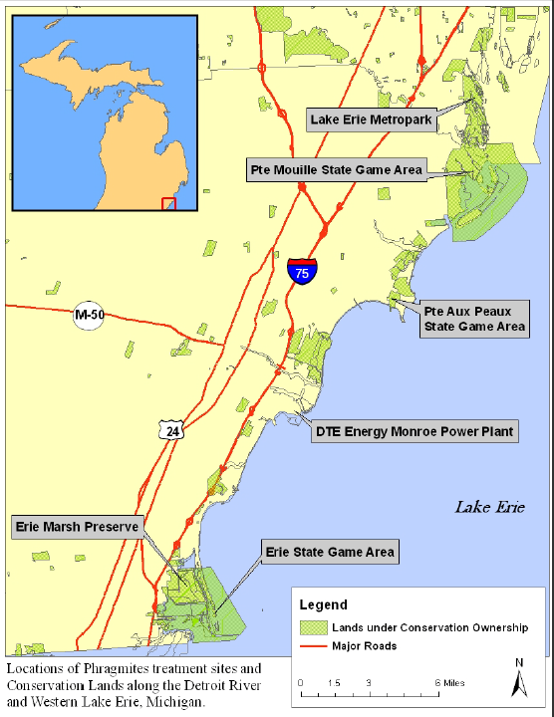
- Eliminate 1,249 acres of Phragmites in infested coastal and near-coastal marsh habitats from northern Maumee Bay to the Detroit River
- Expand and preserve native plant communities
- Increase stopover habitats, increase food supplies and natural cover for migrating birds, and expand habitat for nesting and resident animal species
- Improve spawning and nursing habitat for native fish species
- Restore the highly altered water regimes within both open and impounded coastal wetlands
Locations of Phragmites treatment sites along the Detroit River and Western Lake Erie
- Improve access for recreational activities, such as boating and fishing, as well as ‘viewscapes’ throughout the coastal area.

Link to overarching WLEB Strategies:
- Implement innovative and resilient on-the-ground habitat restoration projects
- Integrate ecological and human well-being values to create a shared vision, engaging a broad spectrum of public and private interests
- Direct restoration investments and inform management decisions

Project summary: Progress toward restoring coastal marshes throughout the Great Lakes has been significantly undermined by the proliferation of non-native, invasive species. Over 180 non-native species (terrestrial and aquatic) presently exist in the Great Lakes. Some have become so prolific and damaging that widespread treatment is needed to enhance Great Lakes’ ecosystem health.
For Western Lake Erie coastal wetlands, one of the most ruinous threats is the spread of non-native Common Reed (Phragmites australis). Phragmites alters the environment of wetlands by excluding native species, reducing plant diversity, and modifying coastal processes. Consequently, near monotypic stands of this invasive plant have replaced high quality, complex communities over thousands of acres in WLE wetlands and coastal areas.
The Nature Conservancy, along with a spectrum of public and private partners, including Huron-Clinton Metroparks, Michigan DNR, and Detroit River International Wildlife Refuge, will collaborate to eradicate invasive Phragmites on approximately 1,200 acres of coastal wetlands within the Western Lake Erie Basin, from the Detroit River to northern Maumee Bay. This invasive species project is unique in that the partners have established a mechanism for long-term eradication after initial control has taken place through the use of a Marsh Master amphibious vehicle. The lands included for restoration are accessible to a vast population which can no longer use these wetlands because of Phragmites. A large-scale, cooperative, and sustained approach to Phragmites treatment in this region will add wetland resources where millions of people live and bring back whole plant and animal communities and functioning wetlands once again.

Key partners:
- Huron-Clinton Metropolitan Authority
- Michigan Department of Natural Resources
- U.S. Fish and Wildlife Service - Detroit River International Wildlife Refuge
- EPA-Great Lakes Restoration Initiative

Project timeframe: All phases complete by 2015
Phase I: Initial herbicide application, summer/fall 2012
Phase II: Follow-up mechanical treatment and/or prescribed fire, late winter 2013
Phase III: Spot-treatment of sites where Phragmites re-growth occurs, summer/fall 2013,
2014, and 2015
Phase IV: Additional management techniques (e.g., water level manipulation) as
appropriate where infrastructure exists.

