Costs of Implementing Conservation and Restoration Actions

Marxan achieves an optimal solution by selecting geographic areas that meet user defined goals for features while minimizing costs. For the WLECCV analysis, Marxan balanced the contribution of each 10ha planning unit towards achieving the goals for each feature against any associated costs. To represent the costs of implementing conservation and restoration actions, we identified seven cost layers, four of which are characterized in monetary values derived from conservation and restoration projects, and three of which are indices reflecting landscape attributes that affect the feasibility of effective conservation (Table A1). Each cost layer is summarized below in terms of its relevance to conservation, the methods for constructing the layer, and a few additional details.

Cost | Units
Land value | $
Wetland restoration cost | $
Phragmites treatment cost | $
Marinas cost to wetlands | Index
Lake Erie and Detroit River stress index | Index
Landbird habitat restoration cost | $
Walleye stream habitat restoration cost | Index

Table A1. Costs of implementing conservation and restoration actions in the coastal areas of western Lake Erie.

Land Value
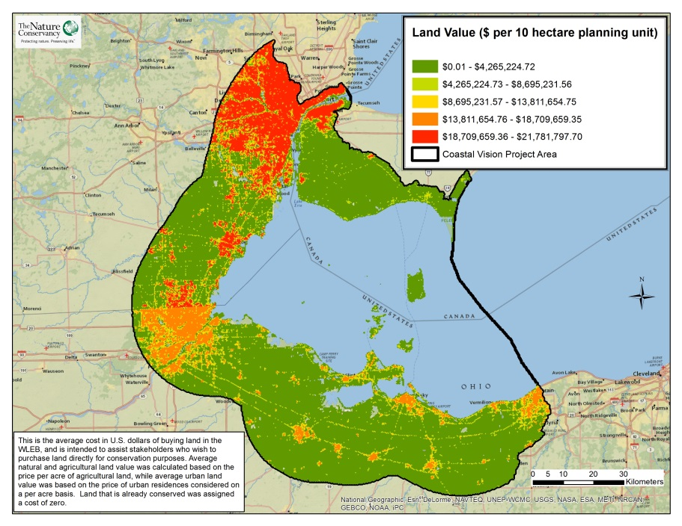
This layer comprises the average cost in US$ of buying land in the WLEB coastal area, and is intended to assist stakeholders who wish to purchase land directly for conservation purposes. For most of the project area, average values for undeveloped and agricultural lands were calculated based on the price per acre of agricultural land, while average urban land value was based on the price of urban residences considered on a per acre basis. This cost layer applies to the entire geography, making it possible for stakeholders to determine the approximate cost of purchasing land in various places in the basin. For example, someone interested in creating a new wetland area can see from this cost layer that buying a parcel of land near the mouth of the Maumee River is significantly more expensive than buying land further east along the southern coast of Lake Erie. With this information, it is now possible for this stakeholder to consider the cost of the parcel when determining the optimal location for the new wetland.
Data layer construction
This layer was constructed from average costs of agricultural and developed lands in the WLEB. The cost of agricultural and other undeveloped land was calculated using the average cost of agricultural land in Ohio, Michigan², and Ontario³ (Table A2). The cost of developed land was based on the median home values in the region, as per acre urban land values were not found to be available. Developed land values were computed separately for Michigan, Ohio, and Ontario. For the U.S., we first calculated median home value by county using the value of homes owned by residents in the 45-54 age class, which is the class with highest valued homes. This data was obtained from the City-Data website (www.city-data.com). We assumed that the average home occupied a ¼ acre lot, so the final average home value was multiplied by 4 to give a per acre land value. In Ontario, the cost of urban land was based on the average listing price of a four bedroom home in Windsor, Ontario, for 2013 obtained from a report by Coldwell Bankers⁴. The land value on inhabitable islands in the Ohio portion of Lake Erie was calculated separately, due to the higher value of islands relative to the mainland. We obtained recent costs of conservation transactions for inland and lake front properties on several of these islands from the Lake Erie Islands Chapter of the Black Swamp Conservancy, and then adjusted the land values to align with these transactions. Land on the Ontario and Michigan islands was also evaluated and found to have very similar value to the mainland areas, and therefore were not treated separately. Lands already in conservation ownership were assigned a value of US$0.00 since they are already protected. This included most public lands, conservation lands, and private hunt club lands.

Jurisdiction | Category | Value ($US per acre)
Michigan | Ag/natural | $4,220
Michigan | Urban | $879,720; ($219,930/home)
Ohio | Ag/natural | $5,000
Ohio | Urban | $685,872; ($171,468/home)
Ohio | Lake Erie Islands (undeveloped) | $7,091
Ontario | Ag/natural | $7,029
Ontario | Urban | $757,680; ($189,420/home)
Table A2. Values used in each jurisdiction and category in the Land Value cost layer.

Data Details
It would be ideal to build this data layer from sources that give urban land values per acre; in the future this layer may be rebuilt with census data that was previously unavailable. Median home values have been used as a proxy for urban land value, but the type of data available is inconsistent between countries, with median values divided by age class and county for the U.S. but only an overall median home value is available for Ontario. Using averages across the landscape gives a general picture of costs, but does not account for small-scale variations, such as the difference in land value in business versus residential districts. The contact for this data layer is Gust Annis.

2 https://www.msu.edu/~steind/2012%20MI%20Land%20Values%20Leasing%20Rates%20NO%20643_Final%20Ve rsion.pdf
3 Agricultural land values in the Essex region of Ontario were estimated based on the Essex Forests and Wetlands Natural Area Conservation Plan (Nature Conservancy Canada, 2009).
4 http://hlr.coldwellbanker.com/PressRelease.html

Wetland Restoration Cost
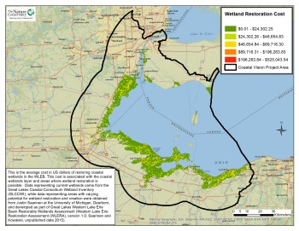
This is the average cost in US$ of restoring coastal wetlands in the WLEB. This cost is associated with the current and restorable coastal wetlands layer, which shows current wetlands and areas where wetland restoration is possible. The cost layer is designed to inform stakeholders of the expense of restoring wetlands along the coast by considering the size, restoration potential, and number of owners of a given coastal parcel. The cost layer also incorporates the average cost of restoration activities associated with all wetland restoration projects, such as native plant restoration and the removal or construction of water control structures like dams, culverts, and channels. A high cost planning unit, for example, is a unit with a low restoration potential, a large area, and many associated land owners, due to the difficulty of negotiating with many owners, and of actually carrying out restoration work across a large area that is not easily converted to wetland habitat. This layer is intended to help stakeholders determine the most cost-effective locations for wetland restoration work along the Lake Erie coast.
Data Layer Construction
The data used to calculate this layer includes four major components. The first is the Current and Restorable Coastal Wetlands layer, created by project staff to provide the acreage of current and potential coastal wetlands. Next is the average restorability index, which indicates the level of difficulty of restoring wetlands and was provided as part of the Western Lake Erie Restoration Assessment by Justin Saarinen of the University of Michigan Dearborn and Kurt Kowalski of the US Geological Survey and covers the US coast except for the Detroit River. For the remaining US and Ontario coastal area, project staff developed a surrogate restorability index following the same principles but using coarser data. The third component is the number of owners in a given planning unit. The final component is a generalized cost estimate of $6,000 per acre for wetland restoration, provided by restoration practitioners Christopher May and James Cole. The data components for this layer are very complete, but it should be noted that the wetland restorability layer for the Detroit River corridor and the Ontario coast is rough; replication of the Western Lake Erie Restoration Assessment layer should be a priority.
Data Details
The wetland restorability index and number of owners per unit area were each divided by 50 to ensure that the resulting values fit a reasonable scale. This layer is complete, but there are notably extreme values at a fine scale in some areas; for example, many of the planning units in urban areas have very high costs due to high ownership complexity. As stated above, opportunities to replicate the wetland restorability index in Canada need to be explored.

In general, there is a concern that the costs associated with wetland restoration are relatively complete while the costs of restoration of surrounding areas has not been accounted for; this “stacking up” of costs may cause Marxan to be biased against restoration in some wetland areas in favor of areas where costs have not yet been assigned. The contact for this data layer is Doug Pearsall.

Phragmites Treatment Cost
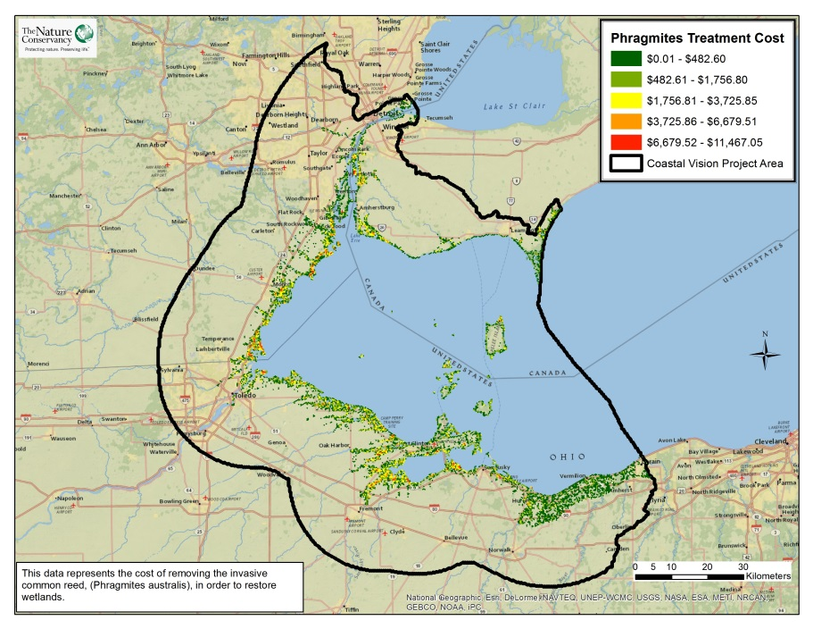
This layer estimates the cost of removing the invasive common reed, (Phragmites australis), in order to restore wetlands. The on-the-ground removal method considered in this layer is a three year process involving aerial spraying of Phragmites in the first year, and follow-up spot removal of remaining Phragmites during the following two years. This process is estimated by experienced TNC practitioners to cost approximately $500 per acre. Areas with high treatment costs therefore reflect areas with large amounts of Phragmites, which means removing all Phragmites will be expensive.
Data Layer Construction
Data depicting the location of Phragmites along the entire coast of the WLEB were developed by the
Michigan Tech Research Institute. This layer was constructed by multiplying each acre of Phragmites by $500, the estimated cost of removing Phragmites. The Phragmites data captures patches of that are larger than 0.2 ha, which is acceptable for this analysis but inevitably misses numerous emerging infestations.

Data Details
This data layer was derived from separate US and Canadian sources. The contact for this data layer is Doug Pearsall.

Marinas Cost to Wetlands
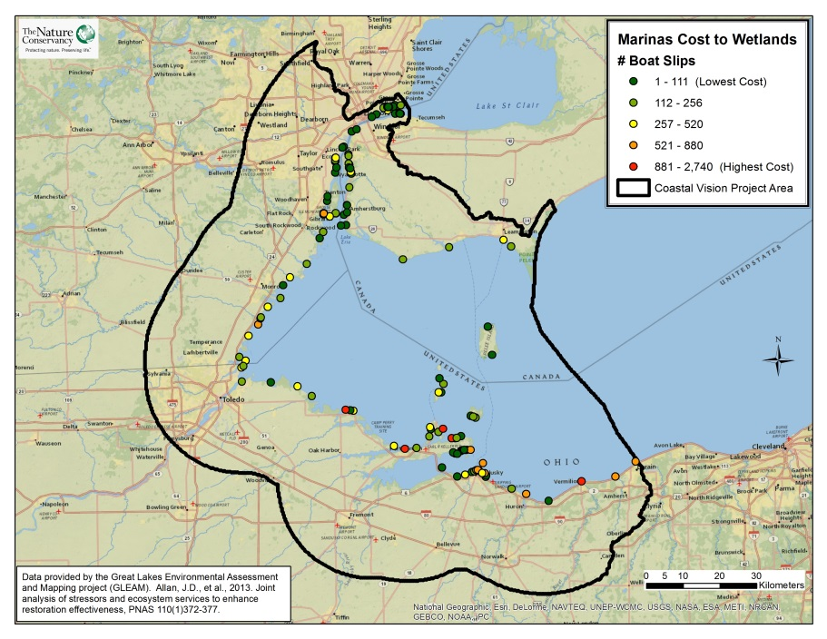

This layer shows where the presence of marinas hinders the restoration of coastal wetlands. Docks and boating ramps in marinas cause shoreline hardening and take up space that might otherwise be filled with wetland plants, and intensive activity associated with marinas creates wakes, pollution, and noise disturbance to wetland wildlife. Conservation practitioners will naturally look to other locations for creating and restoring wetland areas.
Data Layer Construction
This data layer was obtained from the Great Lakes Environmental Assessment and Mapping (GLEAM) Project. GLEAM provided locations and the number of boat slips at each marina. We assumed that marinas with more boat slips would represent a higher cost to conservation, so we derived cost values from the number of boat slips within each project planning unit hexagon. The contact for this data layer is Gust Annis.

Lake Erie and Detroit River Stress Index
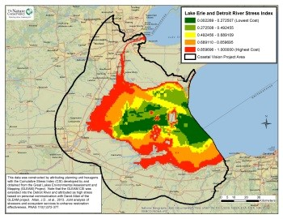
This layer is an index representing multiple stressors that likely have an impact on biota and ecosystem dynamics. The index represents cumulative stress for 34 different stressors which can be physical, chemical, or biological resulting from human activity. According to the Great Lakes Environmental Assessment and Mapping (GLEAM) Project, who developed the data, these stressors can be divided into seven different categories including aquatic habitat alterations, climate change, coastal development, fisheries management, invasive species, nonpoint source pollution, and toxic chemical pollution.
Data Layer Construction
The GLEAM research team identified and mapped 34 stressors across the Great Lakes at a 1 km² resolution excluding connecting channels. They then developed weightings of the relative impact of each stressor on habitat types using the results of a survey of Great Lakes experts. Finally, the Cumulative Stress Index was developed by summing all of the stressors for each grid cell. A detailed account of this data layer can be found at http://www.greatlakesmapping.org/lakes-stressors. TNC computed and assigned the mean stressor index to each planning unit hexagon in the project area. Note that the GLEAM CSI was extended into the Detroit River and attributed as high stress based on personal communication with David Allan of the GLEAM project. The contact for this data layer is Gust Annis.

Landbird Habitat Restoration Cost
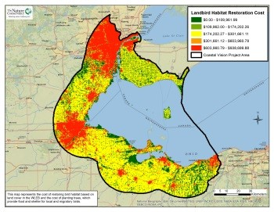
This layer represents the cost of restoring bird habitat based on land cover in the WLEB and the cost of planting trees, which provide food and shelter for local and migratory birds. This layer is applied across the inland geography, as it is intended to relate specifically to landbirds. The cost of restoring landbird habitat is estimated at US$7,441 per acre, adjusted to account for the influence that variation in current land cover will have on restoration cost. Urban areas were considered to have a high cost for restoration, agricultural areas a relatively low cost, and natural areas to have almost no cost. Stakeholders interested in planting trees and shrubs to restore landbird habitat will find this layer useful.
Data Layer Construction
This data layer was produced by first estimating the per-acre cost for restoring landbird habitat. We based the estimate on three actual restoration projects, two of which were implemented on DTE Energy property with costs of $9,000 and $8,000 per acre, respectively. The third project was implemented by TNC’s Oak Openings program in Ohio, and cost $5,324 per acre. The average cost of these three projects – rounded to the nearest $100 – provides our estimate of $7,441 per acre. We then established a multiplier based on land cover data from the NOAA Coastal Change Analysis Program (CCAP) for the U.S. and the Ontario Ministry of Natural Resources Provincial Land Cover (PLC) project for Canada; the PLC data lacked roads, so we “burned” roads into the PLC using infrastructure data accessed through Land Information Ontario. We classified these data into three categories including natural, agricultural, and urban land cover, and multiplied the base cost estimate by the average multiplier value within each 10ha planning unit.
Data Details
In order to scale the cost of restoration, a multiplier was applied to each of the three defined low, medium, and high cost areas—which are roughly equivalent to natural, agricultural, and urban areas, respectively. A multiplier value of 5 was applied to high cost areas, while multipliers of 1 and 0.5 were respectively applied to agricultural and natural land cover. It should be noted that land cover data for Canada did not have as many classes as U.S. data. The contact for this data layer is Doug Pearsall.

Walleye Stream Habitat Restoration Cost
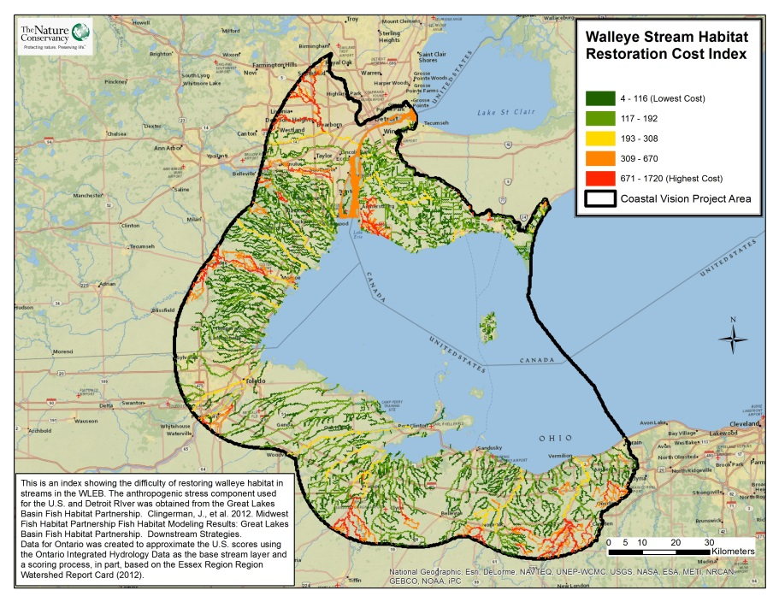

This layer is an index showing the difficulty of restoring walleye habitat in streams in the WLEB. A threat score was assigned to each stream portion using information about barriers to stream flow, size of the stream, and anthropogenic stress on the stream system. Higher costs were assigned to streams of large size, blocked flow, and high levels of anthropogenic stress. This data layer can be used to prioritize streams where restoration projects are likely to have the lowest cost and thus be most successful.
Data layer construction
This data layer was constructed using a formula that multiplied anthropogenic stress, stream size, and stream connectivity together to produce overall costs for restoring various stream areas. The anthropogenic stress component used for this layer for U.S. steams and the Detroit River was obtained from the 2012 Great Lakes Basin Fish Habitat Partnership report by the National Fish Habitat
Partnership (NFHAP). The report calculated a Cumulative Anthropogenic Stress Index (CASI), which was found to be most influenced by stream network wetland land cover, local road crossing density, local groundwater consumption, stream network superfund site density, and local National Pollutant Discharge Elimination System site density. The TNC team multiplied the CASI value for each stream by stream size and by a connectivity score. Stream connectivity and size was determined from TNC data developed for the Lake Erie Biodiversity Conservation Strategy. Connectivity was scored on a presence-absence basis, while streams were categorized into four size classes. Data for Ontario

streams was created to approximate the U.S. scores using the Ontario Integrated Hydrology Data as the base stream layer and a scoring process, in part, based on the Essex Region Watershed Report Card (2012)¹⁷ where streams in watersheds receiving Watershed Health grades of “C” were assigned a score of 50 and those receiving a grade of “D” were assigned a score of 75. Any streams in watersheds with grades of “Unknown” were assigned a score of 75. Then the same process of multiplying these base scores by a stream size and connectivity score as described above for the U.S. streams was applied.
Data Details
Multipliers were applied to the connectivity and stream size scores in order to account for the increased difficulty of restoring streams with barriers to flow and large overall size. In regard to connectivity, a value of 1 was entered for streams connected to the lake and a value of 5 was entered for streams with barriers to flow. For stream size, a multiplier of one was input for the smallest size class, and multipliers of two, three, and four were applied as size class increased, respectively. In the future, it may be necessary to adjust the analysis to account for the connection of polygons that follow a stream’s flow, but this is unlikely to be needed. The contact for this data layer is Gust Annis.

Essex Region Watershed Report Card, 2012. http://erca.org/wp-content/uploads/2013/03/watershed-report2012-single-pg-for-web.pdf

http://ohioagmanager.osu.edu/farm-rents/farmland-value-and-rent-outlook-2013/
Obtained from the Great Lakes Coastal Wetland Consortium’s Wetland Inventory (http://www.glc.org/wetlands/inventory.html).
This institute also developed a website with further information about Phragmites: http://www.mtri.org/phragmites.html.
Allan, J.D., et al., 2013. Joint analysis of stressors and ecosystem services to enhance restoration effectiveness, PNAS 110(1)372-377. http://www.greatlakesmapping.org
Allan, J.D., et al., 2013. Joint analysis of stressors and ecosystem services to enhance restoration effectiveness, PNAS 110(1)372-377. http://www.greatlakesmapping.org
Tylenda and Cousino, 2013: http://glmigratorybirds.org/action.html#.UnO1p1MljFc
Personal communication, Jennifer Thieme, Conservation Project Coordinator at TNC Kitty Todd Preserve
http://www.csc.noaa.gov/digitalcoast/data/ccapregional/
http://library.mcmaster.ca/maps/ogde_plc.htm
Clingerman, J., et al. 2012. Midwest Fish Habitat Partnership Fish Habitat Modeling Results: Great Lakes Basin Fish Habitat Partnership. Downstream Strategies. http://midwestfishhabitats.org/sites/default/files/glb.pdf
http://fishhabitat.org/partnership/great-lakes-basin-fish-habitat-partnership
http://cfpub.epa.gov/npdes/
Pearsall, D., P. Carton de Grammont, C. Cavalieri, C. Chu, P. Doran, L. Elbing, D. Ewert, K. Hall, M. Herbert, M. Khoury, D. Kraus, S. Mysorekar, J. Paskus, and A. Sasson. 2012a. Returning to a Healthy Lake: An International Biodiversity Conservation Strategy for Lake Erie. Technical Report. The Nature Conservancy, Nature Conservancy of Canada, and Michigan Natural Features Inventory, Lansing, MI, 340 pp. with appendices. Available at http://www.conservationgateway.org/ConservationByGeography/NorthAmerica/UnitedStates/michigan/projects /biodiversity/Pages/default.aspx 17 Essex Region Watershed Report Card, 2012. http://erca.org/wp-content/uploads/2013/03/watershed-report2012-single-pg-for-web.pdf

