Migratory Bird Stopover Habitat
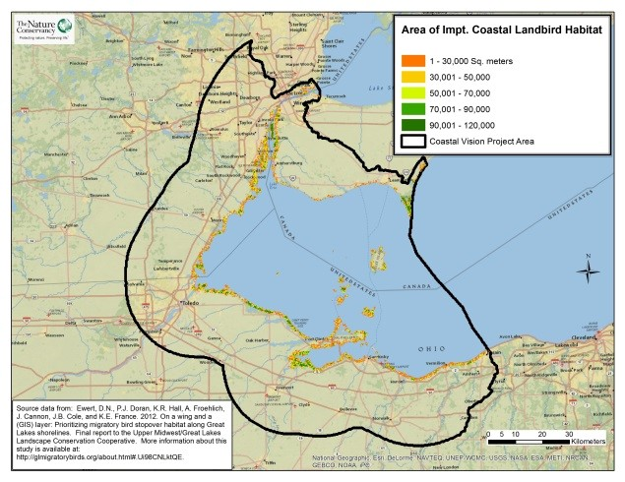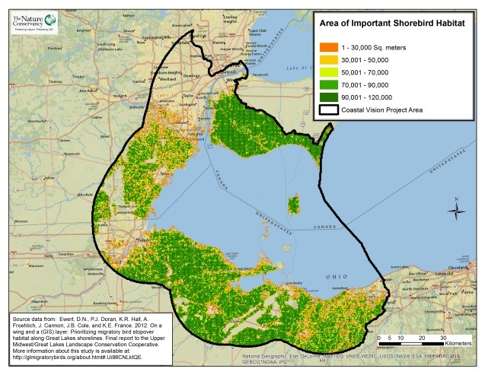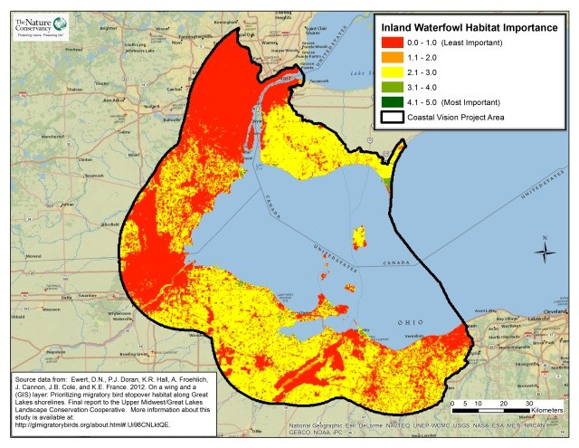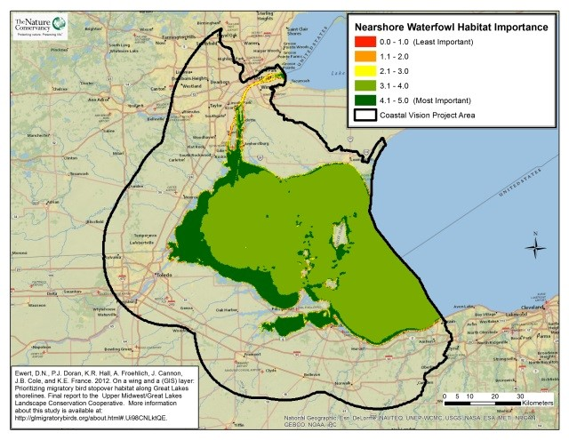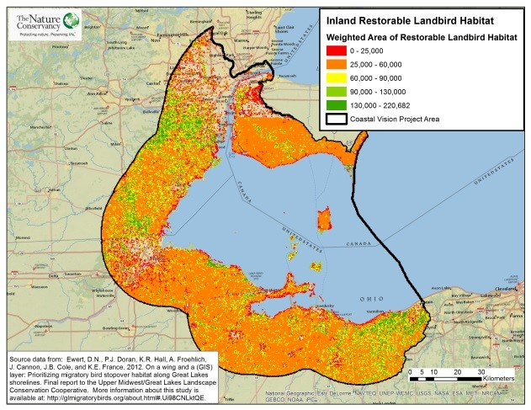
Take Home Points
- The WLEB is an important corridor for birds migrating to and from the southern United States south to Argentina.

- The preservation of stopover sites is crucial for both the biodiversity of the lake basin and the continued presence of migratory species

- The seasonal diversity and abundance of birds attracts birders from around the world, significantly impacting the region’s economy (an estimated $35 million on food, gas, lodging and other expenses).

- The LEBCS set four targets for improving landbird, shorebird and waterfowl habitat quality by 2030.

A

Migratory Bird Stopover Habitat. The study area is outlined in black. The suitability of land cover for bird habitat is shown on a gradient from red (least suitable) to green (most suitable). Five types of stopover habitat are depicted: A) Nearshore Waterfowl Habitat, B) Inland Restorable Landbird Habitat, C) Inland Waterfowl Habitat, D) Shorebird Habitat, and E) Coastal Landbird Habitat.

D
C
E
B

Migratory birds in relation to regional ecological and social values
Located at the intersection of the Mississippi and North Atlantic Flyways, the Western Lake Erie Basin (WLEB) is an important corridor for northern birds migrating to and from the southern United States to Argentina. Songbirds, waterfowl, shorebirds, hawks, owls, and other species that travel through this region are dependent on food and shelter offered by the Western Lake Erie shoreline and inland stopover habitat during the high-stress periods of spring and fall migration. In turn, the huge numbers of migrating birds represent an important component of the food chain by eating millions of insects and fruits and dispersing seeds along their route. The preservation of stopover sites ensures the survival of these birds, which is critical for both the biodiversity of the lake basin and the continued presence of these species in their southern range. This makes conservation efforts in the Lake Erie basin both locally and internationally important. In addition to their ecological role, migratory birds are treasured by the many bird enthusiasts who visit or live in the region. The seasonal diversity and abundance of migrating birds attract birders from around the world, who collectively benefit the region’s economy by spending an estimated $26 million on food, gas, lodging, and other expenses related to their visit to the Lake Erie coast¹. The WLECCV project acknowledges migratory birds as an important target for conserving WLEB biodiversity and the tourism industry that depends on these species.
Related Human Well-being layers: eBird

Migratory Bird Stopover Habitat data layers
The Lake Erie Biodiversity Conservation Strategy (LEBCS) set the following 2030 goals for the WLEB: 1) At least 30% of the 2 km coastal area comprises high quality stopover habitat for migrating landbirds; 2) at least 10% of coastal area comprises high quality stopover habitat for migrating shorebirds; 3) at least 50% of the 2 km coastal area, including coastal wetlands, comprises high quality stopover habitat for migrating waterfowl; 4) at least 80% of the 2 km coastal area that is high quality stopover habitat for all bird groups is in conservation ownership or management². The WLECCV project incorporated the habitat scores from a recent study by Ewert et al. (2012) for each of the three bird groups and separated them into five categories: coastal landbird habitat (0-1.6 km from shore), inland restorable landbird habitat (1.6 -25 km from shore), shorebird habitat (≤25 km of shore), nearshore waterfowl habitat (from Lake Erie shore to 15 m depth), and inland waterfowl habitat (islands and up to 25 km inland of Lake Erie shore). These data layers facilitate achievement of LEBCS goals by depicting existing stopover habitats for shorebirds, waterfowl, and landbirds (coastal only), and restorable inland habitat for landbirds, thus indicating where conservation efforts best accomplish these goals. Ewert et al (2012) identified and scored attributes of stopover sites and potential stopover habitat, such as land cover data and proximity to water bodies, within 25km of the Lake Michigan, Huron, Erie, and Ontario shorelines, and their connecting water bodies³. The criteria used in the study to predict the locations of stopover sites are based on a literature review and on unpublished information from reports and regional stopover experts; further study method details are available online.
The inland restorable landbird stopover habitat layer incorporates current stopover habitat (Ewert et al. 2012) and restorable habitat in two categories: highly restorable and moderately restorable habitat. These additional areas were identified by recoding landcover data (Provincial Land Cover for Ontario, and CCAP for the US). For example, pasture and hayfields were placed in the highly restorable category, and low intensity developed land was placed in the moderately restorable category. Each of these categories was assigned a value (1 for current habitat; 0.5 for highly restorable habitat; 0.25 for moderately restorable habitat) and the total area of each category was multiplied by these weighting values to calculate a final value for each 10-ha hexagon.
Data sources and potential limitations
The Nature Conservancy is developing a web portal that will allow the public to access stopover maps and report information. The primary land cover data sets used for this layer were published in 2006 (US) and 1999 (Canada). Consequently, changes in land use since that time have not been captured in the analysis; this is an inevitable limitation of data availability at the time of the project.

References and links
- http://ohioseagrant.osu.edu/research/economic/?ID=R/ME-033#benefits
- Pearsall, D., P. Carton de Grammont, C. Cavalieri , C. Chu, P. Doran, L. Elbing, D. Ewert, K. Hall, M. Herbert, M. Khoury, D. Kraus, S. Mysorekar, J. Paskus and A. Sasson. (2012). Returning to a Healthy Lake: Lake Erie Biodiversity Conservation Strategy. Technical Report. A joint publication of The Nature Conservancy, Nature Conservancy of Canada, and Michigan Natural Features Inventory. 340 pp. with Appendices.
http://www.conservationgateway.org/ConservationByGeography/NorthAmerica/wholesystems/greatlakes/Pages/lakeerie.aspx .
- Ewert, D.N., P.J. Doran, K.R. Hall, A. Froehlich, J. Cannon, J.B. Cole, and K.E. France. (2012). On a wing and a (GIS) layer: Prioritizing migratory bird stopover habitat along Great Lakes shorelines. Final report to the Upper Midwest/Great Lakes Landscape Conservation Cooperative.

Contacts: Migratory bird data layer WLECCV analysis
Dave Ewert Doug Pearsall
The Nature Conservancy The Nature Conservancy
dewert@tnc.org dpearsall@tnc.org

