Recreational Fishing
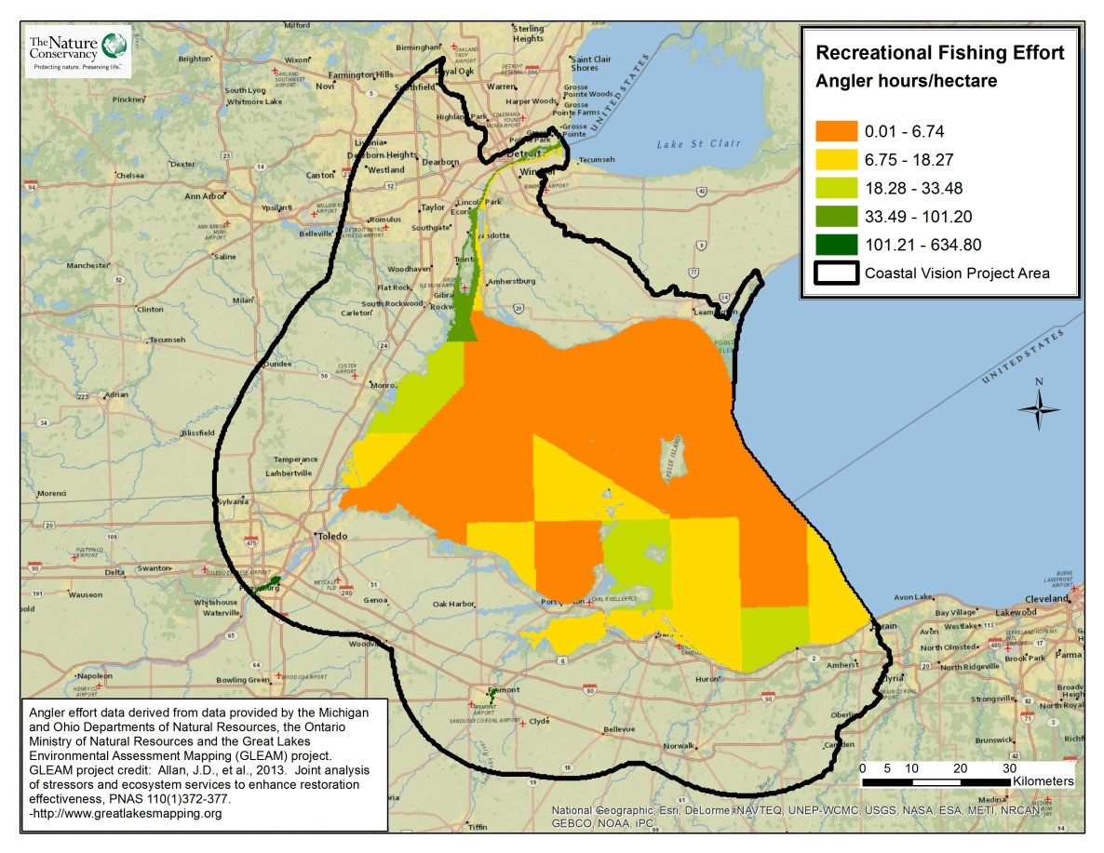
Take Home Points
- Millions of anglers fish in Western Lake Erie annually

- Fishing in the Western Lake Erie Basin (WLEB) is an important source of local revenue; anglers on a typical day trip on Lake Erie spend an average of US$42-98 per person

- This layer shows the number of angler-hours spent in the Ohio, Michigan, and Ontario portions of the WLEB

Recreational Fishing. The density of recreational fishing effort is represented by angler-hours per hectare, with green indicating the greatest number of angler-hours and red indicating the least number. The WLEB study area is outlined in black.

Recreational fishing in relation to regional ecological and social values
Recreational fishing provides an opportunity for people to interact with nature. Some studies have found that recreational fishing is the most popular outdoor activity among adults, with over 1,664,000 anglers fishing on the Great Lakes in 2011¹. Thirty-eight percent of those anglers chose to fish in Lake Erie during 2011—this is 10 percent more than the number of anglers who visited Lake Michigan, making Lake Erie the most popular fishing destination in the Great Lakes Basin². Fishing provides participants with light to moderate exercise, access to nature, and an important food source. Fishing within the Western Lake Erie Basin (WLEB) is also an important source of income and revenue, with the expenditures for a typical day trip on Lake Erie totaling between US$42-98 per angler³. Between 2006 and 2011, the number of anglers fishing in the Great Lakes region increased by 17 percent and contributed US$1.9 billion to the Great Lakes’ economy, illustrating the increasing importance of fishing to the local economy⁴. Recreational and sport fishing also provides ecological benefit to the region in the form of tax revenues generated from the sale of fishing licenses, a portion of which is dedicated to habitat preservation and restoration. Numerous sport fishing tournaments take place within the WLEB on an annual basis, giving fisherman from around North America the chance to compete on some of the most abundant fishing grounds in the Great Lakes. Walleye are so highly valued by the sport fishing industry in the United States that commercial fishing interests are not permitted to catch walleye on the American side of the border⁵. This layer was used to ensure that this highly valued activity was included in the analysis.
Relation to Ecological layers: Walleye Spawning Areas, Walleye Lake Habitat, Walleye Stream Habitat, Coastal Wetland Restoration

Recreational Fishing data layer
The recreational and sport fishing layer represents the fishing value of WLEB waters in terms of angler-hours, which vary slightly between the Ontario, Ohio, and Michigan areas of the WLEB. The WLECCV Project team compiled this layer from data provided by the Michigan and Ohio Departments of Natural Resources, the Ontario Ministry of Natural Resources, the Great Lakes Environmental Assessment and Mapping (GLEAM) project, and several published creel surveys. The assessment unit size for the U.S. and Canadian sides of the lake, and for the rivers, varied substantially; for example, the U.S. side of the lake is divided into 5-minute grid cells, while the Canadian side is divided into several uneven assessment units. All areas of the WLEB, including the Detroit, Maumee, and Sandusky Rivers, were converted into hectares to create a uniform data layer for the analysis. Similarly, angler-effort data for a mix of walleye, yellow perch, white bass, and smallmouth bass were received from several sources of varying measurement units that were subsequently converted into angler-hours for the analysis.
Data sources & potential limitations
The recreational fishing data layer was compiled using data from a number of different sources. Angler-hour data for fishing of all species in the Michigan portion of Lake Erie were obtained through personal communication with the Michigan Department of Natural Resources. Angler-hour data (2008) for walleye, yellow perch, white bass, and smallmouth bass fishing were obtained through communication with the Ohio Department of Natural Resources. The Ohio DNR also provided angler-hour data (2013) for walleye fishing in stretches of the Maumee and Sandusky River that they had previously identified as the most intensely fished areas. Angler-hours for walleye, yellow perch, and smallmouth bass fishing in the Ontario portion of Western Lake Erie were digitized based on data provided in a 2008 survey by the Ontario Ministry of Natural Resources⁶. Detroit River angler-hours for walleye, yellow perch, and white bass fishing on the Canadian side were digitized from a 2009 Creel survey by the Ontario Ministry of Natural Resources⁷. Angler-hours for the Michigan side of the Detroit River were provided through personal communication with a member of the Great Lakes Environmental Assessment and Mapping (GLEAM) project; this data includes both charter fishing (2010-2012) and private fishing (2002-2004). No angler effort data was available for Michigan or Ontario streams.

References & Links
- American Sportfishing Association (2013) Sportfishing in America: An Economic Force for Conservation. Accessed online on 2/18/2014 via http://asafishing.org/facts-figures/sporfishing-economics/sportfishing-in-america/
- U.S Department of the Interior, U.S. Fish and Wildlife Service, and U.S. Department of Commerce, U.S. Census Bureau. 2011 National Survey of Fishing, Hunting, and Wildlife-Associated Recreation. www.census.gov/prod/2012pubs/fhw11-nat.pdf
- U.S. data gathered from U.S. Fish and Wildlife Service. 2011. National Survey of Fishing, Hunting, and Wildlife-Associated Recreation. Michigan and Ohio Summary Files. Accessed online on 2/19/2014 via http://www.census.gov/prod/www/fishing.html. Canadian data gathered from Fisheries and Oceans Canada. 2008. Survey of Recreational Fishing in Canada: Selected Results for the Great Lakes Fishery, 2005. Accessed online on 2/19/2014 via http://www.dfo-mpo.gc.ca/stats/rec/gl/index-eng.htm.
- U.S. Fish and Wildlife Service. 2011 National Survey of Fishing, Hunting, and Wildlife-Associated Recreation-National Overview. August 2012. USFWS. www.doi.gov/news/pressreleases/upload/FWS-National-Preliminary-Report-2011.pdf ; U.S Department of the Interior,
U.S. Fish and Wildlife Service, and U.S. Department of Commerce, U.S. Census Bureau. 2011 National Survey of Fishing, Hunting, and Wildlife-Associated Recreation. www.census.gov/prod/2012pubs/fhw11-nat.pdf
- www.miseagrant.umich.edu/explore/about-the-great-lakes/lake-erie/
- Belore, M., K. Ho, and R. Drouin. 2008. Summer angler survey in the Canadian waters of the Western Basin of Lake Erie. Ontario Ministry of Natural Resources: Lake Erie Management Unit.

- Soper, K., and B. Locke. 2010. Summer creel census in the Canadian waters of the Detroit River. Ministry of Natural Resources: Lake Erie Management Unit.

Contact
Gust Annis
The Nature Conservancy in Michigan
gannis@tnc.org

