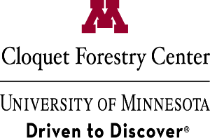
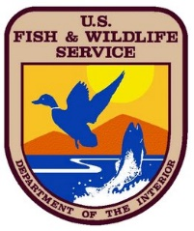
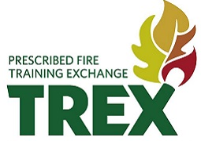
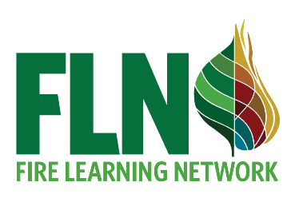
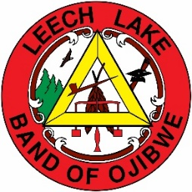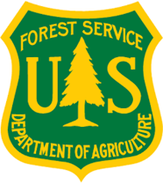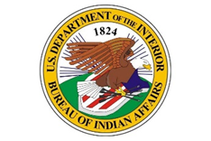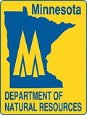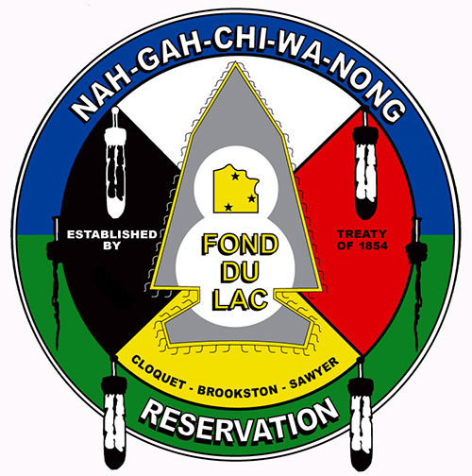
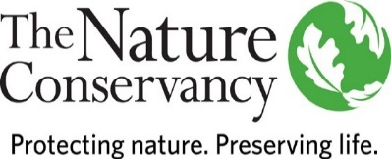
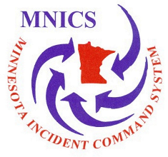

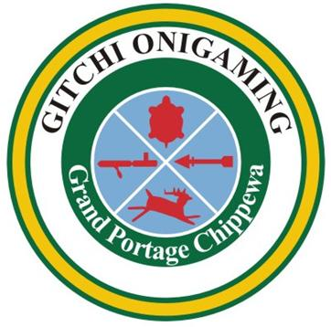
*TRAINING ANNOUNCEMENT*
Minnesota Northwoods
Prescribed Fire Training Exchange (TREX)
Event Dates: MAY 4 – MAY 17, 2020
Application Deadline: MARCH 15

Objectives:
- This two-week event aims to facilitate inter-agency and peer-to-peer experiential learning
for fire professionals, and others interested in ecological burning to restore fire-adapted ecosystems.
- Training: Participants will serve in both NWCG qualified trainer and trainee positions on a team and will assist with preparing, scouting, briefing, igniting, holding, mop-up, and patrol on controlled burns.
- Treatments: Provide added capacity to prescribed fire practitioners throughout Northern Minnesota’s diversity of fuel types and ecosystems to accomplish various management objectives.
- Outreach: This training will incorporate knowledge from Tribal partners of Minnesota and develop understanding about their traditional and contemporary use of fire to manage cultural resources.
Target Group:
- This training is designed to integrate a diverse group of wildland fire personnel, including: Federal, State, Tribal, University, Volunteer, NGO, resource managers, scientists, and researchers.
- Trainee positions most applicable to Northwoods TREX: FFT1, FEMO, FIRB, ENGB, & RXB2
  - Potential trainee positions on US Forest Service hosted burns: TFLD and ICT4
Description:
- We will train with equipment, practice fire line leadership, learn about local fire ecology and landscape restoration projects through field exercises, workshops, presentations, field trips, fire effects monitoring, and prescribed burning.
- Day to day activities will change depending on conditions - we may burn one day, prep a burn unit the other, and attend a field trip the day after.
- To learn more about cooperative burning model of TREX events, visit the Conservation Gateway.

Requirements:
- Current and qualified NWCG FFT2 or RXCM minimum and have completed NWCG courses S-130, S-190, L-180, ICS-100, IS-700A and able to provide documentation. These courses are available for self-study online and can be found here NWCG requirements.
- Completed arduous pack test (moderate for RXCM) within last 12 months before arrival at TREX.
- Participants must have health insurance which will cover personal injury (e.g., workers’ comp, health or travel insurance) they may sustain during TREX.
- Participants should come with all appropriate Personal Protective Equipment (PPE), including NFPA approved fire boots, Next Generation Fire Shelter, hard hat, Nomex clothing, all leather gloves, eye protection and canteens for drinking water. If you do not have proper PPE, please let us know.
- Commitment to attend and participate in the two-week training event.
Registration Fee:
- $300 Please note: registration fee is not pro-rated based on the amount of time at TREX.
- Participants and employers are responsible for all paid and/or vacation time, including overtime, accrued during TREX. Registration fee to be used for administrative purposes.
Meals & Travel:
- Participants are responsible for travel to and from the event. Meals and Lodging will be provided and organized by TREX staff during the event.
  - For special dietary needs, please indicate any restrictions on the application.
- Participants should be prepared to camp if needed and bring their own tents, sleeping bags and pads.
What to Expect:
- Treat this event like a full 14-day assignment. The schedule and mix of activities will be contingent upon weather and fuel conditions that will dictate when, where, and how training will take place.
- As a participant your role may also change throughout TREX. You may be in a leadership position or you may be working to support the team to provide others the opportunity to lead and learn.
- TREX staff will do their best to create as many position task book training and evaluation opportunities as safely possible. However, no guarantee can be made regarding the number of trainee assignments that will be available or the completion of position task books during TREX.
Registration:
- To apply, complete the application form below and submit to paul.priestley@TNC.org by March 15, 2020
- Space for 25 participants. Agenda and more details will be included in registration packet.
This training is supported by Promoting Ecosystem Resilience and Fire Adapted Communities Together, a cooperative agreement between The Nature Conservancy, USDA Forest Service and agencies of the Department of the Interior.
An equal opportunity provider

MINNESOTA NORTHWOODS PRESCRIBED FIRE
TRAINING EXCHANGE (TREX) APPLICATION
May 4 - 17 2020
Submit application to paul.priestley@TNC.org by March 15, 2020
Please save document with your last name.
I. Participant Information
Full name:
Agency/Organization and position:
Work address (street, city, state, zip/postal code, country):
Work phone: | Cell phone: | Email:
II. NWCG Qualifications (current)
Qualified positions:
Trainee positions:
Positions you are confident to train others:
III. In Case of Emergency
Name: |  |  | Phone number(s):
Relationship (family, supervisor, friend, other):
IV. Medical Information and Diet
Do you have any allergies, medical problems or other conditions that could affect your ability to conduct prescribed fire or take part in other field exercises? If so, please describe below.

Vegetarian? Food allergies or other dietary restrictions?
V: Event Expectations
Briefly describe your expectations for the training. What do you expect to learn, to bring to the course, and to experience? How will this benefit your workplace, organization, and career?

VI: Available Equipment
Will you have the ability to bring any engine resources, trucks, or other equipment?

VII: Supervisor Information
Name: |  | Phone:
Job title:

