6 Minutes
for Media

Prescribed Fire Training Exchange

Niobrara Valley Preserve, Nebraska

March 8-22, 2014

Why is media training important?

Public understanding and support for the work that fire workers do is critical to the success of our mission to manage fire and conduct controlled burns. Every fire worker - from local volunteers to agency leaders in Washington, DC and everyone in between - is responsible for helping educate people about fire management. The “6 Minutes for Media” daily discussion points will provide you with some basic media knowledge as well as tips for achieving successful interviews.

But why interviews and why me?

- Most people learn about fire primarily by reading, watching, and hearing various sources of media.
- The news media strongly influences public perception of fire through its portrayal of fire workers and major fire incidents.
- You are the subject matter expert, and the public respects and listens to your opinion. In fact, studies have shown that fire fighters are more believable than many other sources of information.

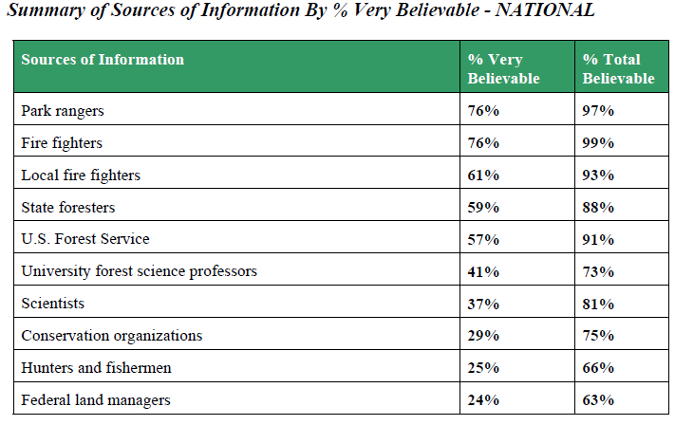

- Key Messages for the 2014 Niobrara Valley Preserve TREX:

- Safety is paramount. That’s why we burn when we do and why we anchor into previously burned areas, perform extensive planning, relentlessly monitor weather conditions, meet national standards for fire workers, and coordinate with local fire departments and other highly experienced personnel. Recent wildfires - not just in Nebraska but also across the U.S. - were an important reminder of the urgent need to proactively manage our forests and grasslands. Tree thinning, grazing, and controlled burns are proven to reduce flammable vegetation and help lessen the potential for future catastrophes.
- Fire training is necessary and important.
- Like rain, fire is critical in the Great Plains.
- Pay now, or pay later.
- The next generation of fire workers, managers, and conservationists are taking fire leadership seriously.
- Building on past successes and lessons learned, the training exchanges have grown every year, attracting more partners and participants from around the U.S. and the world.
- Wildfire effects, such as erosion and large numbers of dead tree skeletons standing across the landscape, are dramatic reminders of what the combination of unchecked, excessive fuel loads and drought will produce.

***Portions of the information contained in this document were adapted from A Guide to Successful Media Interviews (NIFC, 2009), located at: http://www.nifc.gov/PIO_bb/Background/NIFC-MediaInterviewGuide2009-Landscape.pdf.

