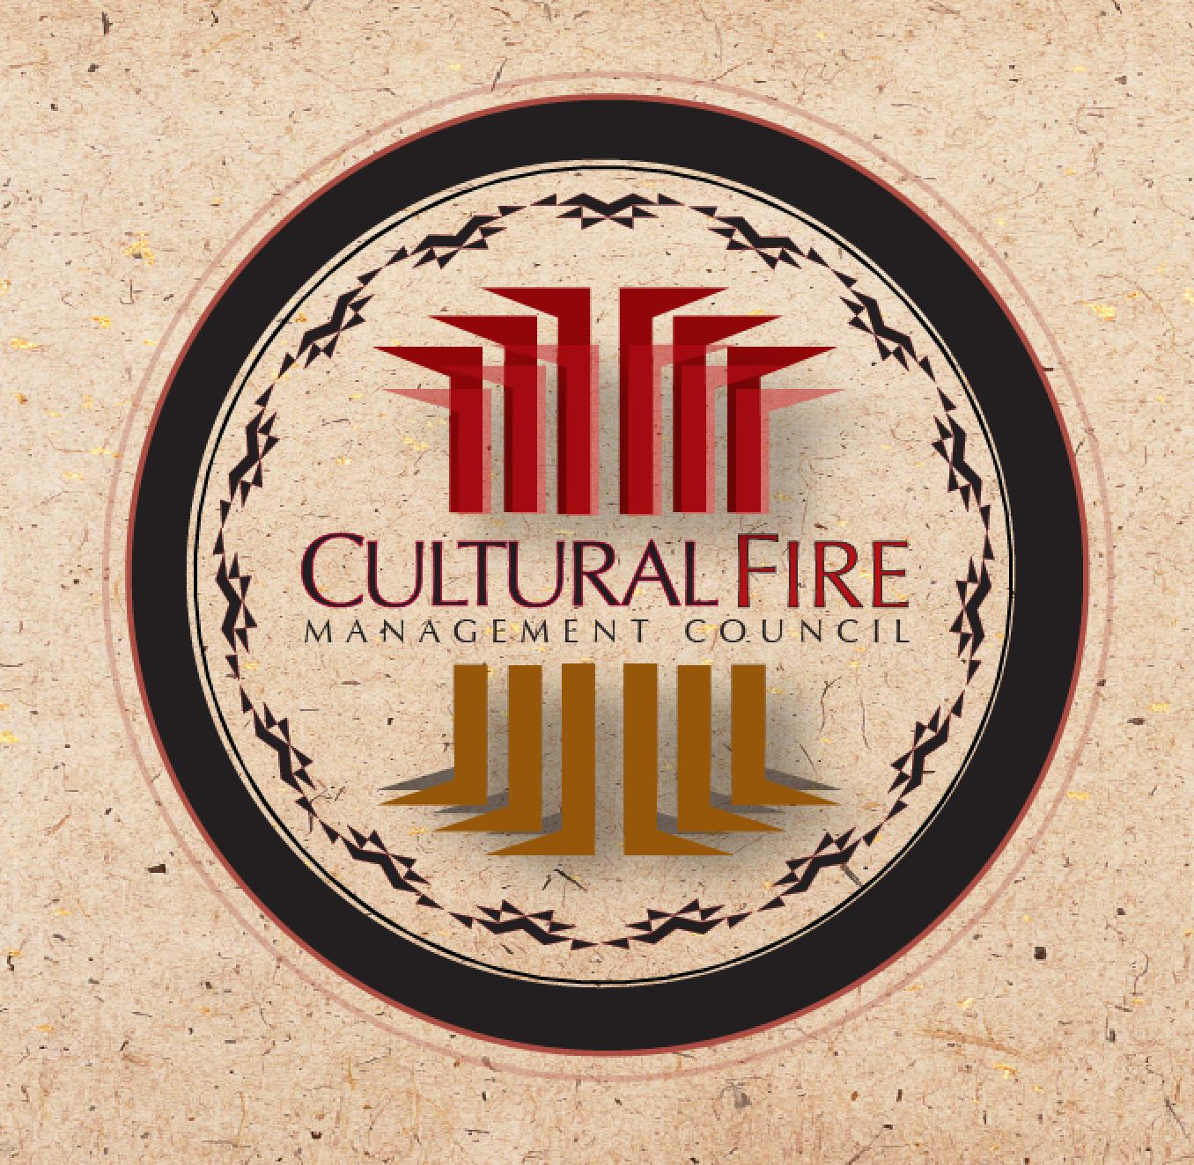

Training Announcement
Name of TREX — Location, ST
Date Range

Objectives: Provide prescribed fire training opportunities to local and regional fire practitioners while supporting management of cultural resources. This training will incorporate knowledge from the native tribes of Northern California and develop understanding about their traditional and contemporary use of prescribed fire.
Target Group: Prescribed fire and wildfire personnel, including federal, state, tribal, and non-governmental agencies, private practitioners and university faculty and students.
Registration Fee: The fee is $300. The fee for university students is $100. Waivers are available for participants who bring equipment (e.g. engines, UTVs, etc.) Please note that the registration fee is not pro-rated based on the amount of time at TREX.

Description: The training is organized as a Type III incident under the National Incident Management System Participants will serve in NWCG qualified and trainee firefighting positions on a burn team and will assist with preparing, scouting, briefing, igniting, holding, mop-up, and patrol on numerous controlled burns in the area. We will also complete pre- and post-fire monitoring, train with equipment, practice fire line leadership skills, and learn about local fire ecology and fire management.

Requirements:
- Participants must be current and qualified NWCG-FFT2, or have completed NWCG courses S130, S190, L180, ICS 100b, I700A. Contact [insert person and contact info] for more information on these trainings; verification of training is required to attend.
- Participants must complete an arduous pack test within the past year. Completion of a moderate pack test is acceptable if coming as a TNC volunteer and serving in an RxCM (Rx crewmember) position.

- Participants must have health insurance which will cover personal injury (e.g., workers’ comp, health or travel insurance) they may sustain during the training exchange;
- Participants must bring fire-approved boots (all leather, 8-inches tall, Vibram soles, with no steel toe). Participants should come with all appropriate Personal Protective Equipment (PPE), including: a Next Generation Fire Shelter, a hard hat, Nomex clothing, all leather gloves, eye protection and canteens for up to 1 gallon of drinking water. If you do not have proper PPE, please let us know. For an additional $50, you can rent a complete set; please indicate your needs on the application.

Meals & Travel: Participants are required to bring their own tents, pads and sleeping bags. Bathrooms, showers and indoor meeting space with internet will be available. Meals will be provided.

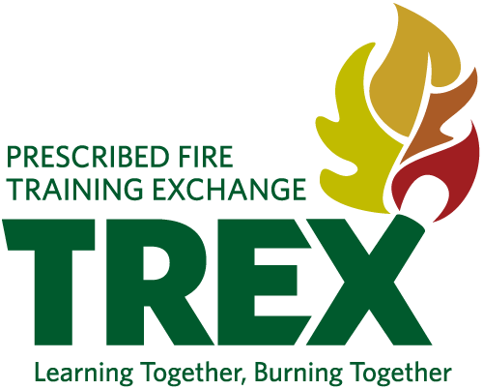
Registration: To apply, complete the application form & submit to [person, email address] by January24, 2020.

