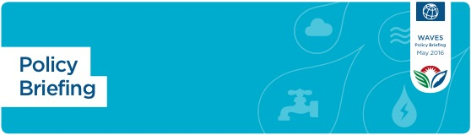

**WAVES**

Policy Brief

MAY 2016

**Policy**

**Brief**

**Valuing the Protection Services**

**of Mangroves in the Philippines**

**Mangroves and other coastal ecosystems act as natural defenses to reduce the risks from flooding, erosion and natural disasters. Yet the value of these habitats is often not fully accounted for in policy and management decisions, and thus they continue to be lost at alarming rates. Using natural capital accounting, we can measure and value the services provided by these coastal ecosystems, and thus inform policies for sustainable development, disaster risk reduction, and environmental conservation. A new report shows how to measure and value the coastal protection benefits of mangroves in the Philippines1.**

**Key Points:**

* Mangroves provide the most protection for frequent lower intensity storms (for example, 1-in-10 year storm events). For more catastrophic events, such as the 1-in-25 year storm, they provide more than **US $1.6 billion** in averted damages throughout the Philippines. When combined with built infrastructure, mangroves provide an effective defense against storms and coastal flooding.
* Based on the Philippines’s current population, the mangroves lost between 1950 and 2010 have resulted in increases in flooding to more than 267,000 people every year. Restoring these mangroves would bring more than **US $450 million/year** in flood protection benefits.
* If the current mangroves (data from 2010) in the Philippines were lost**, 24% more people** would be flooded annually, i.e., an additional **613,000** more people many of whom live in poverty.
* Damages to residential and industrial property would increase by 28% to more than **US $1 billion** annually; and **766 km of roads** would be flooded.
* One hectare of mangroves in the Philippines provides on average more than **US $3200/year** of direct flood reduction benefits.

**Background _**

This brief is part of a collaboration between The World Bank WAVES Program, The Nature Conservancy (Michael Beck, Siddharth Narayan, Dania Trespalacios), and The Environmental Hydraulics Institute of Cantabria (Íñigo J. Losada Rodríguez, Pelayo Menéndez Fernández, Pedro Díaz Simal, Antonio Espejo Hermosa). Additional support provided by the German International Climate Initiative.

**Summary _**

Coastal habitats can protect people and property from storms, floods, and erosion, reducing coastal risk. Natural capital accounting can ensure that these ecosystem services are valued and accounted for in policy and management decisions. In the Philippines, significant expanses of mangroves have been lost in the last century, increasing coastal risk2. A recent study demonstrates that mangroves significantly reduce risks from flooding in the Philippines. Using high-resolution flooding models, the study compares flooding for scenarios with and without mangroves under different storm conditions, and estimates the expected benefits of mangroves for protecting people and property in social and economic terms to help inform decision making.