  - Resilient Nature, Resilient People

Global Climate Change Program
adaptation@tnc.org
http://conserveonline.org/workspaces/climateadaptation

http://conserveonline.org/workspaces/climateadaptation

http://conserveonline.org/workspaces/climateadaptation

http://conserveonline.org/workspaces/climateadaptation

RECONNECTING FLOODPLAINS: Protecting Communities & Ecosystems in a Changing Climate

Rivers flood. It's a natural phenomenon as elemental as earthquakes or drought. When rivers overflow their banks the water moves out onto adjacent lands, releasing the minerals and nutrients that make floodplains one of the most productive and biodiverse ecosystems on the planet.
For human societies drawn to rivers for their beauty and bounty, flooding poses real challenges and risks. We have built thousands of dams and hundreds of thousands of miles of levees as engineered lines of defense against floods. Today, however, even with this extensive investment, damages continue to rise: In the United States alone, flooding takes a $6-billion-a-year toll in property damage. The destruction is escalating around the world as population increases are putting pressure for housing and other development on the floodplains that serve as nature's high-water sponges.
The current flood-prevention infrastructure isn't working for the environment either: Without natural periodic inundations, floodplains are losing species five times faster than their terrestrial counterparts. And all of this comes at a time when scientists are predicting that climate change will increase the severity and frequency of both floods and droughts. Throughout much of North America, Asia and central Africa estimates suggest that climate change could increase surface runoff by as much as 75 percent by the end of this century.
ECOSYSTEM-BASED ADAPTATION
The Nature Conservancy believes we can simultaneously reduce the risk of floods and improve the productivity of floodplains, increasing our resilience to the impacts of climate change. This ecosystem-based adaptation strategy reconnects rivers to their floodplains. The Nature Conservancy is pursuing this approach in a number of places. Rather than trying to control flooding with dams and other rigid structures, this approach uses floodplains as green infrastructures that allow periodic flooding over fields and meadows. Instead of holding back high waters, floodplains store and absorb them. This approach to a human and environmental problem, an example of ecosystem-based adaptation, focuses on making people and their communities more resilient to climate change by restoring natural ecosystems and promoting the flood protection benefits they provide to society.
In California, a floodplain project has been serving Sacramento-area communities and ecosystems since the 1930s. Just west of the state capital, the Yolo Bypass absorbs 80 percent of the Sacramento River's floodwater during large storm events. It reconnects a 59,000-acre area to the river that drains the northern half of the state. When it is not flooded, this area grows rice and pastures cattle. When it storms, the floodplain routes high waters away from the city. The flooded area provides essential habitat to migratory birds and other species. During a March 1986 flood, the Yolo Bypass carried more than three times the total flood storage capacity of all the reservoirs in the region. Without it, California would need to build massive dams and reservoirs or allocate more of its already strained water-supply storage to flood control.
Removing or setting back strategic levees on a large scale requires a major shift in the way we think about rivers and floodplains. It also requires funding. The Nature Conservancy has outlined several ways to make these changes economically and politically viable. The land itself is one source of revenue. As illustrated by the Yolo Bypass, floodplains that flood periodically can still provide fertile agricultural production under private ownership. In addition to pastures, agricultural uses compatible with periodic flooding include timber production and flood-tolerant crops such as switchgrass and willow for biomass fuel sources. In the Western United States and other places where flooding is seasonal, farmers can grow annual crops in the dry season.
Another economic incentive involves changing the way multi-purpose reservoirs are managed. Most are saddled with the dual responsibilities of keeping reservoirs empty to capture floodwaters and keeping them full to provide water for hydroelectricity, municipalities and irrigation. Shifting the burden of flood control from reservoirs above dams to their historic floodplains below relieves the pressure to reserve space for floodwaters. That allows managers the flexibility to store water for hydroelectric production, municipal water supply or irrigation, all sources of revenue. The Nature Conservancy is coordinating feasibility studies on China's upper Yangtze River to determine how much additional hydropower income a cascade of four dams under construction would generate by eliminating flood storage in the reservoirs and managing the flood risk in downstream floodplains.
For much of the world, floodplains are critically important to people for their livelihoods and sustenance. Because floodplains support productive food webs, they drive the freshwater fisheries that are fundamental to many local economies. Maintaining and restoring floodplains is critical to the welfare of these communities. The Mekong River fishery, for example, provides jobs and food to more than 60 million people.
Other economic benefits of floodplains may be less obvious but also have great value: water filtration; sediment, nutrients and carbon sequestration; groundwater recharge and storage. The Nature Conservancy is monitoring the level of these and other ecosystem services in Louisiana, where several partners have reconnected the Ouachita River to a 15,800-acre floodplain. Along with potential revenue from water filtration and storage, floodplains provide additional benefits including recreation, open space and the vital habitat on which so many species depend.
The Nature Conservancy's floodplains reconnection approach comes at a time when climate scientists are predicting hydrological extremes around the globe. The challenges posed by this unknown future can be mitigated by reconnecting rivers to their historic floodplains, allowing them to serve as a hedge against the uncertainties of a changing climate. Working with the Army Corps of Engineers, the Conservancy is studying options on the Delaware River to reduce flooding, which threatens water supplies for nearly 20 million people, by protecting wetlands and a floodplain forest of increasingly rare butternut trees.
Reconnecting rivers to their floodplains could transform how we live with rivers as well as how we adapt to a changing climate. Instead of paying more for flood protection and getting less, this innovative approach promises social, economic and environmental payoffs – the triple bottom line. The synergy generated by combining flood reduction with floodplain conservation is helping to safeguard communities and restore natural ecosystems.
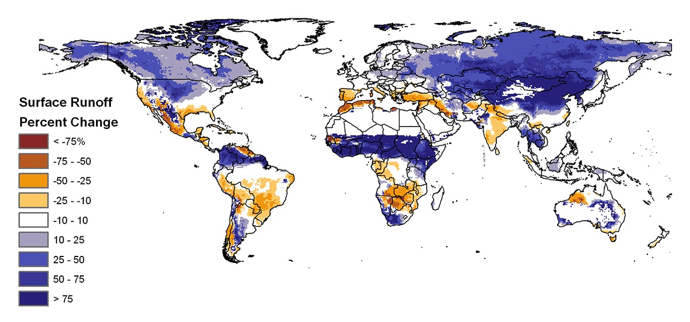
Future projected change in runoff during 2060 based on the average of sixteen climate models. Blue colors represent increasing runoff and brown colors represent decreasing runoff. From research by Prof. Jennifer Adam, Washington State University.

Future projected change in runoff during 2060 based on the average of sixteen climate models. Blue colors represent increasing runoff and brown colors represent decreasing runoff. From research by Prof. Jennifer Adam, Washington State University.

