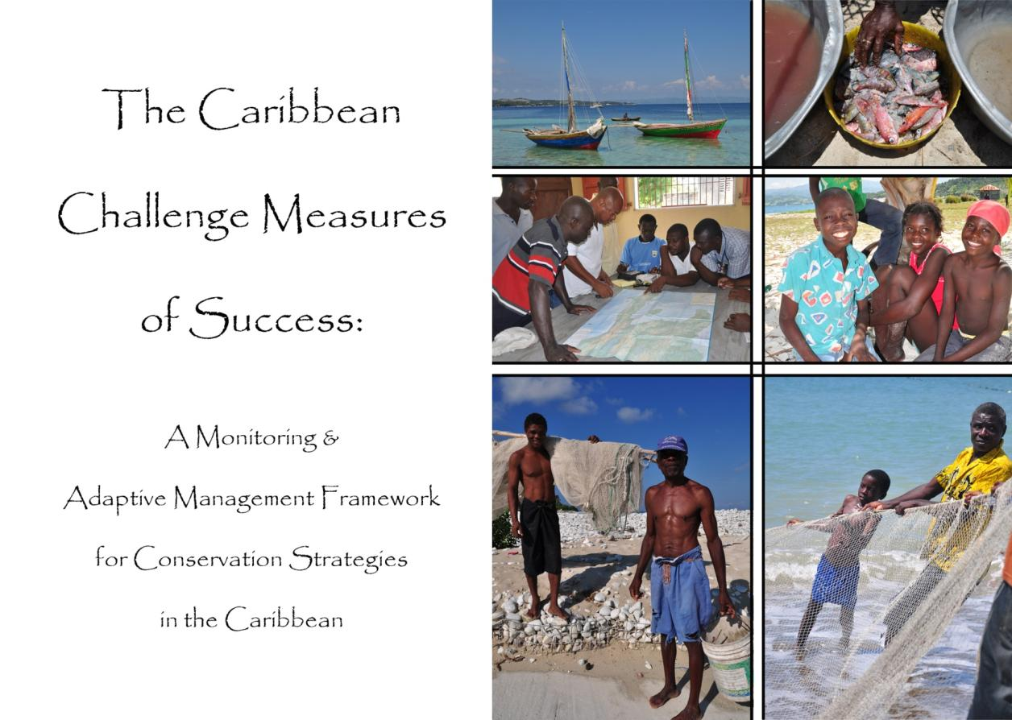

**The Caribbean Challenge Initiative Measures of Success**

*A Monitoring & Adaptive Management Framework for Conservation Strategies in the Caribbean*

Contents

**The Caribbean Challenge Initiative Measures of Success** 2

INTRODUCTION 3

The Caribbean Region 3

Caribbean Challenge Initiative (CCI) Overview and Strategies 5

Rationale for CCI Measures 6

Objectives and Timeline of Measures Development 6

Phase 1: January to June 2011 7

Phase 2: July 2011 to June 2012 7

METHODS & RESULTS 8

Strategy Effectiveness Measures: Sustainable Financing of Protected Areas 8

Strategy Effectiveness Measures: Expansion and Enhancement of Marine Protected Areas 14

Measures Implementation in Caribbean Challenge Initiative 18

ACRONYMS 19

Appendix I: Detailed Monitoring Table for Regional Sustainable Finance Strategy 20

Appendix II: Caribbean Challenge Initiative implementation in the Dominican Republic 23

Sustainable Financing of Protected Areas 23

Protected Area Management Effectiveness and the Improvement of Ecosystem Services 24

Appendix III: Caribbean Challenge Initiative implementation in the Bahamas 28

Appendix IV: Caribbean Challenge Initiative implementation in Jamaica 32

Appendix V: Caribbean Challenge Initiative implementation in the Eastern Caribbean 35

Appendix VI: Caribbean Challenge implementation in the Overseas Territories 41

Endnotes 41

# INTRODUCTION

## The Caribbean Region

The Caribbean is a biological and cultural diversity hotspot comprised of 38 million people living in 12 sovereign countries and 17 overseas territories, where at least four major languages (English, Spanish, French, and Dutch) are spoken. Several biodiversity analyses have highlighted the global significance of the Caribbean’s natural systems. The Nature Conservancy’s Caribbean Ecoregional Assessment[1] identified the Caribbean’s eight marine ecoregions as having enabling conditions that would allow significant progress towards achieving the Conservancy’s conservation and human well-being goals. These eight marine ecoregions contain significant coral reefs, sea grasses, and mangroves as well as turtle and seabird nesting sites. According to *Reefs at Risk Revisited*, Caribbean reefs in the tropical western Atlantic realm account for almost 10% of the area of the world’s coral reefs[2]. Similarly, a study concluded by Conservation International[3] identified the islands of the Caribbean as a global hotspot based on the unique species of terrestrial and aquatic plants and animals that are only found in this part of the world.

The Caribbean is highly dependent on the marine and coastal environment for jobs, income, food security and economic prosperity. The majority of the population lives within the coastal zone and the tourism sector, the cornerstone of most Caribbean economies, is inextricably linked to a healthy marine and coastal environment. Tourism brings 25 million tourists to the region every year, generating $25 billion in revenues (about 25% of GDP) and supporting 6 million jobs (one in every four jobs).

While there is an ever-growing body of information documenting the social and economic values of these marine and coastal resources, their long-term health remains largely undervalued by public and private sector leaders. For example, it is estimated that only 8%[4] of the nearshore and coastal shelf (out to 200m depth contour) is legally protected. Of these existing protected areas, a vast majority of them are ‘paper parks,’ being poorly financed and severely lacking in management capacity. The Caribbean’s coastal and marine resources are also facing increasing pressures such as, unsustainable coastal development and tourism growth, coastal pollution, overfishing and climate change that are threatening the future of these marine and coastal resources. This low level of protection and investment, combined with unprecedented threats, put these resources, Caribbean people – and the region’s future economic prosperity – at great risk.

Collective and decisive action is needed to stem this trend. The Caribbean Challenge Initiative (CCI) is an effort to chart a new course for protecting and managing the precious marine and coastal resources of the region.This document outlines a framework for evaluating progress on the Caribbean Challenge Initiative, an effort primarily geared to sustainably protect Caribbean marine ecosystems. This adaptive management framework will guide the evaluation of conservation strategies and help to determine the return on investment for the Initiative.

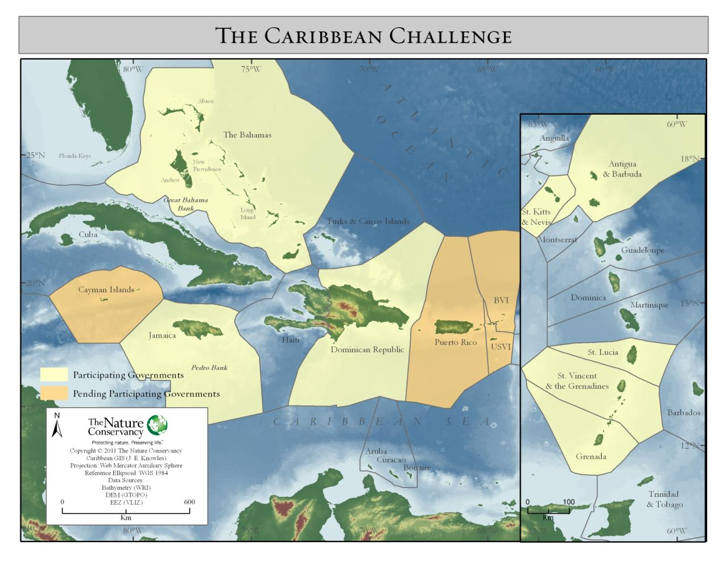

Figure : Countries (including their Exclusive Economic Zones) participating in the Caribbean Challenge

## Caribbean Challenge Initiative (CCI) Overview and Strategies

The Caribbean Challenge Initiative is a joint effort by regional governments, donors and conservation organisations to build political support and generate long-term funding to protect at least 20 percent of participating countries’ marine and coastal areas by 2020. Under the Initiative, these governments have committed *to protect at least 20% of their near-shore marine / coastal environment by 2020, through comprehensive national systems of marine and coastal protected areas.*

Toward achieving this 20% target, these countries have also agreed on two objectives:

1. to put in place an innovative, *new financial architecture that will secure sustainable funding* for their protected area systems (i.e. reliable, long-term sources of dedicated funding)
2. to take actions that will help ecosystems and coastal communities adapt to climate change—an approach known as “*ecosystem-based adaptation*”

Eight sovereign Caribbean nations - Antigua & Barbuda, The Bahamas, The Dominican Republic, Grenada, Jamaica, St. Kitts & Nevis, St. Lucia, and St. Vincent and the Grenadines- and The Conservancy are actively engaging in the first phase of the Caribbean Challenge Initiative laying the groundwork for sustainable funding and conservation actions. TNC has played an instrumental role in catalyzing the CCI, and continues to play a key coordination and support role. Other countries and territories (e.g. Cayman Islands) are starting to express an interest in joining this effort. There is therefore potential for all of the countries and territories in the Insular Caribbean to eventually join this initiative.

TNC’s goal for the CCI is to **increase the protection of biodiversity and safeguard human livelihoods across the Caribbean through sustainably managed protected area systems that are resilient to climate change and degradation.**  This will be achieved through the following strategies:

* By 2020, conserve (or make significant progress towards conserving) at least 20% of the Caribbean’s coastal and marine habitat in effectively managed protected areas[5] across participating countries.
* By 2015, create dedicated and permanent funding for Caribbean protected area systemsthrough the establishment of Protected Areas Trust Funds and the creation of *new* sustainable finance mechanisms.
* By 2015, develop projects focused on ecosystem-based adaptation to climate change and tools to protect key threatened habitats and livelihoods.

## Rationale for CCI Measures

Quantifying the return on time and resources invested in activities and measuring progress towards goals is a necessary and often mandatory process in the business and increasingly in the non-profit world. Also known as results-based management or adaptive management, this cycle of planning, implementation, evaluation and adaptation is an integral part of the Conservancy’s Conservation by Design approach. The effectiveness of conservation actions informs and guides future planning and strategy implementation. Recently, the ‘measures’ component of this cycle received a further boost at TNC with the development of an organizational wide measures business plan with the following aims for FY11 and FY12:

* By June 2012, all Regions and Global Teams have the capacity and processes needed to evaluate the effectiveness of Priority Projects and Strategies, can report on progress toward intended results, and are actively using results in an adaptive management fashion1 to improve conservation Return-on-Investment (ROI).
* 50% of Priority Projects and Strategies are able to measure progress towards long-term conservation outcomes.

Considering the geographical, programmatic, and financial scope of the CCI, it is imperative to consistently and continually measure the effectiveness and implementation success on biodiversity, people and institutions we work with. There is a lot at stake: millions of dollars, 36 years of Caribbean experience[6], political capital in eight sovereign countries, and the health of a vast tropical marine area. Hence the Caribbean Challenge Initiative is high risk, but well positioned to be a pioneer in achieving long lasting conservation for future generations. .

This measures framework provides an important baseline for measuring progress on ecological, human, and sustainable finance objectives for multiple countries. Furthermore, the framework is hoped to be a novel approach to consistently reporting measures at regional, national and site scales. The costs and time involved in developing these measures will be balanced by the significant connections and accountability with various participants and donors, and the increased funding that the framework will provide. The measures framework is aimed at several audiences initially: It will inform TNC Caribbean operations, global executive team and board, as well as select partners. It will also provide the basis for stewardship reporting for major donors that have expressed interest in investing in the Caribbean Biodiversity Fund (CBF).Over time, this framework could be modified and used to provide periodic progress reports for governments.

It must also be noted that this phase in the development of measures for the CCI is being conducted by TNC. It is expected that as the CCI coordination matures and roles are clarified, a more collaborative approach to measures development will be pursued.

## Objectives and Timeline of Measures Development

Since 2008, the Caribbean programme has recognised the need to track the overall progress of the Caribbean Challenge Initiative using compatible metrics across participating countries. The goal of this exercise is therefore to develop a standardized system for measuring and reporting progress of the Caribbean Challenge Initiative by June 2012. There are two temporal scales to the measures framework: a) immediate monitoring of short-term indicators (i.e. protected area expansion and enhancement, sustainable finance); and b) long-term monitoring of long-term indicators (e.g. progress on ecological and human well-being objectives). Indicators will be assessed through sampling designs that account for the level of scientific rigor and geographic inference required to answer specific questions for the above audiences for measures and to effectively trigger appropriate management actions.

Phase 1: January to June 2011:

The aim of this first phase is to plan, initiate, and test the development of measures for the Caribbean Challenge. Beginning in January 2011, the Caribbean science team led a pilot project for the development of Strategy Effectiveness Measures for the MPA and Sustainable Finance components of the Challenge using the Dominican Republic. Phase 1will test the alignment of measures at regional, national, and site scales, resulting is an end product that will be a framework for MPA and Sustainable Finance strategy measures at both regional and national scales.

Phase 2: July 2011 to June 2012

In Phase 2, the following activities will be completed:

1. Develop strategy effectiveness measures for Ecosystem-Based Adaptation (EBA) to climate change.
2. Develop status measures for coral reef ecosystems (coral reefs, mangroves and sea grass beds), threats to biodiversity (e.g. coastal development, overfishing), and socio-economic impacts (e.g. livelihoods, life support, empowerment, cultural significance).
3. Develop national and demonstration site level measures for sustainable fisheries and tourism strategies
4. Develop a standardised and rolled-up reporting mechanism for all measures, e.g. a simple Caribbean Challenge Initiative report card or an online GIS based “dashboard”.

# METHODS & RESULTS

The development of measures for the Caribbean Challenge Initiative started in January 2011 with the core science team meeting to plan the timeline and objectives for the entire exercise. This planning session was guided by lessons learnt from the Forever Costa Rica, the Coral Triangle Initiative and Micronesia Challenge measures development, TNC’s measures business plan and the wider practice of results-based management.

The Dominican Republic (DR) was used as a pilot project since it was relatively far advanced in the development of its strategies and objectives under the CCI. In addition, the programme also needed to develop a measures framework for two very large projects being implemented in the DR: USAID-funded Environmental Protection Programme and a GEF full size biodiversity project. The pilot was aimed at determining the best process for integrating and aligning high level Caribbean Challenge Initiative strategies with the on-the ground priorities and strategies at the country and site level. For each of the two strategies, Specific, Measurable, Achievable, Relevant, and Time-limited (SMART) objectives were drafted as well as a monitoring plan for site, national, and regional scales, where applicable.

The DR pilot was conducted by a small working group (comprising one DR conservation staff and 3 members of the regional science team) via email and web-based conferencing. The main outputs between January and March were a draft measures document for CCI implementation in the DR and corresponding Miradi results chains. These were reviewed at a regional workshop attended by over 30 TNC staff. The workshop provided an opportunity to refine key CCI strategies as this was the first science meeting for the Caribbean Programme since the launch of the Caribbean Challenge Initiative in 2008. Additionally, “national” objectives were drafted for the Caribbean Challenge Initiative geographic groups or “geographies”: The Bahamas, Dominican Republic, Jamaica, the Eastern Caribbean (5 countries) and Overseas territories (see Appendix II).

## Strategy Effectiveness Measures: Sustainable Financing of Protected Areas

Strategy summary: *This strategy includes the development of National Protected Areas Trust Funds (NPATFs), which will receive proceeds of the regional Caribbean Biodiversity Fund (CBF), combined with other revenues, such as from new local conservation finance mechanisms (such as conservation fees, tourism fees, water funds, payment for environmental services, debt swaps) and supported by economic valuation studies to fund the protected area system.*

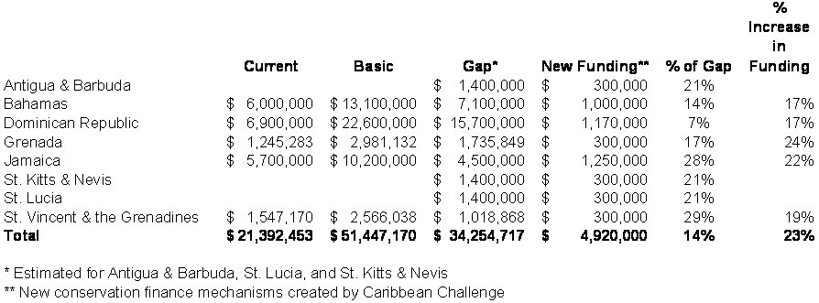

Figure Funding gap in CCI countries based on information contained in GEF documents (UNDP Financial Scorecards) for Bahamas(2006), Dominican Republic (2007), and Jamaica (2008)and/or completed Sustainable Finance Plans for National Systems of PAs  for Grenada (2004)and St. Vincent(2005). N.B. this does not take into account the expanded MPA system – although for both Grenada & St. Vincent a linear estimate of the funds necessary was developed with an expanded PA system and taking into account inflation.

The sustainable finance strategy’s will fill existing funding gaps for A key component of providing sustainable financing to the eight countries participating in the Caribbean Challenge Initiative is the creation of the Caribbean Biodiversity Fund (CBF). The CBF is an eight country regional endowment, with an initial capitalization goal of US$ 40 million. This endowment will fund the National level Protected Area Trust Funds (NPATFs) of the participating countries. The table below demonstrates how the donor grants are being allocated to the countries as separate endowments within the CBF.

Three national GEF projects to capitalize the CBF and launch on-the-ground PA activities (in The Bahamas, Dominican Republic, and Jamaica) are currently in implementation. The sub-regional project for the five countries of the Eastern Caribbean will be submitted to the GEF Council for approval in early 2011. Starting in 2010, the Conservancy has worked with a Trust Fund Specialist (funded by KfW) and a pro bono legal team from the law firm of Ropes and Gray as well as the eight participating countries, KfW, the World Bank (Implementing Agency for the Eastern Caribbean sub-regional GEF project), the United Nations Development Programme (Implementing Agency for the Dominican Republic and Jamaica GEF projects), and the United Nations Environment Programme (Implementing Agency for The Bahamas GEF project) to draft various documents related to the creation of the CBF and National Protected Areas Trust Funds (NPATFs). Critical documents include: the CBF Articles of Incorporation, CBF Investment Strategy, CBF Operations Manual, model NPATF legislation and by-laws, and a Vertical Agreement (which links the CBF to the NPATFs).

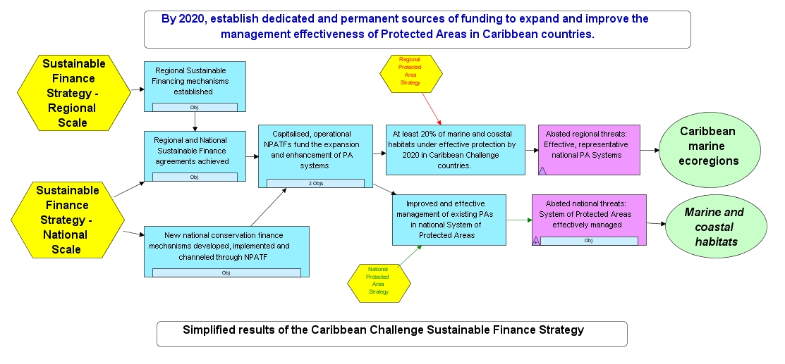

The CBF will operate from an office based in the UK and have a Caribbean-based Secretariat to provide administrative services and day-to-day management. The Conservancy will most likely serve as the Secretariat for a short period on an “acting” basis, until the CBF Secretariat is able to hire its own staff. At a minimum, the CBF Secretariat will have an Executive Director, with other administrative needs outsourced to a financial services firm (selected through an open and transparent process). KfW has agreed to provide a €100,000 (approximately US $130,000) grant to the CBF to assist with the CBF’s start up expenses. Future CBF Secretariat expenses will be covered via retention of a small portion (estimated to be approximately 5-10%) of the CBF annual payout to the NPATFs.



Once the CBF has been officially established as a UK UK-based charity (estimated to take approximately 3 months after initial paperwork has been filed) and the CBF Secretariat has been established, the donors may begin to pass their grants to the CBF. The Conservancy’s $8 million grant to the CBF would be payable over 4 years. GEF funds from the Eastern Caribbean project will be transferred to the CBF on a 1:1 basis of co-financing from KfW and TNC. The Bahamas, Dominican Republic and Jamaica have yet to determine if their GEF funds will be transferred to the CBF. Most likely it will be up the Boards of the NPATFs in these countries to make the decision to transfer these GEF funds to the CBF.

Table : Strategy Effectiveness Measures for Regional Sustainable Financing of Protected Areas

| **Caribbean Challenge Sustainable Financing of PAs**: By 2020 establish, at the regional level, dedicated and permanent sources of funding to expand and improve management effectiveness of national systems of protected areas protected areas in Caribbean countries participating in the Challenge. | |
| --- | --- |
| **Regional Objectives** | **Indicators** |
| **A. By 2012 the Caribbean Biodiversity Fund will be established, functional, initially capitalized, and invested.** | A1. CBF established as a tax exempt charity in the UK |
| A2. CBF Functional: Acting Executive Director named and working effectively in that role; financial services firm hired in an open and transparent process based on conservation trust fund (CTF) best practices. |
| A3. CBF initially capitalized: at least 50% of the KfW funds have been transferred to the CBF and invested by the investment manager hired in a transparent and open process per CTF best practices. |
| A4. CBF perceived as legitimate by key stakeholders (participating governments, national protected area trust fund boards) according to the established standards |
| **B. By 2015, at least 6 NPATFs are operational*, perceived as legitimate and meet all requirements of their vertical agreement* to receive CBF incentive funds.** | B1. 0perational – Non-government majority board established and officers elected; administrative capacity in place; open and transparent process for grant making established - all per CTF best practices, etc. |
| B2. Vertical agreements between the CBF and NPATFs established |
| B3. NPATFs perceived as legitimate by key stakeholders according to the established standards |
| **C. By 2020, NPATFs in 6 Caribbean Challenge Initiative countries are funding activities which improve RAPPAM/METT scores for PA systems toward meeting minimum threshold score (To be further developed)** | C1. Improvements in RAPPAM/METT scores |
| **D. By 2020, 50% (approx $16 million per year*) of annual funding gap for conservation in protected areas closed in 6 countries.** | D1. % reduction in funding gap for PAs per country based on financial scorecard for each country ( or mechanisms for non-countries TBD)country |

Apart from regional activities, the Caribbean Challenge will be supported by country-based activities that will set-up the NPATFs, develop new sustainable finance mechanisms, and ultimately reduce the long-standing gap in financing for protected areas (Table 2).

Table : National level objectives* for Caribbean Challenge Initiative Sustainable Financing Strategy

| **Caribbean Challenge Strategy: Establish, at the national level, dedicated and permanent sources of funding to expand and improve management effectiveness of national systems of protected areas in Caribbean countries participating in the Challenge countries participating in the Challenge.** | | | | |
| --- | --- | --- | --- | --- |
| **General National Objectives** | **Jamaica Objectives** | **Dominican Republic Objectives** | **Eastern Caribbean (5 countries) Objectives** | **Bahamas Objectives** |
| **NPATFs are established and conforming to CBF stipulations** | By Dec. 2012, NPATF established and conforms to CBF stipulations | By May 2012, bylaws for NPATFs conform to CBF stipulations | By 2013, two and by 2015, four conforming NPATFs have been established and operational through participatory process. | By May 2012, bylaws for Bahamas Protected Area Fund conform to CBF stipulations. |
|  |  |  | Parliament passes legislation to create the BPAF by end of 2012. |
| **New sources of protected area funding generated to match CBF proceeds** | By 2015, at least $250k in new, sustainable PA revenues is generated at the local level flows into NPATF and qualifies as match for CBF proceeds. | By 2015, the full local revenue match ($250K) to CBF proceeds go to NPATFs | By 2015 2, and 4 by 2017, the full local revenue match ($150K) to CBF incentives proceeds go to NPATFs | By 2015, the full local revenue match ($500K) to CBF proceeds goes to Bahamas Protected Areas Fund. |
| **Protected area funding gap reduced** | *See above* | By 2020, close 25 % of annual funding gap (as of 2007) for national for national protected area system | By 2020, close50% (approx $700k per year*) of annual funding gap for national protected area systems in at least 4 countries national protected area systems | By 2014, $4 million in TNC and national match commitments for co-financing Bahamian GEF full-sized projects for PAs met |
|  |  | National commitments for GEF co-financing met by all five countries by 2014 |  |

* See Appendix II for the Sustainable Finance strategy indicators

## Strategy Effectiveness Measures: Expansion and Enhancement of Marine Protected Areas

*Strategy Summary: This strategy aims to establish new protected areas and strengthen the management of existing networks of MPAs. TNC will support the 8 countries currently participating in the Caribbean Challenge Initiative to designate, conserve and improve management of the full range of legally designated protected areas, contributing to the fulfilment of targets under the CBD Program of Work on Protected Areas.*

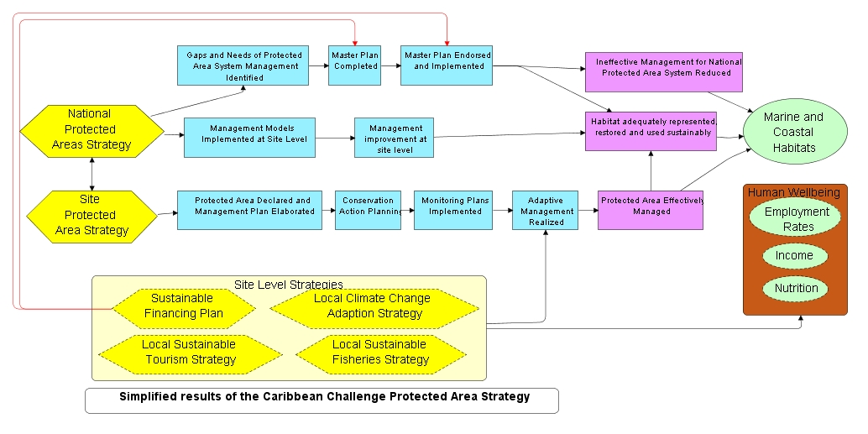

Table : National level objectives* for Caribbean Challenge Initiative MPA Strategy. Note, this does not include the suite of biodiversity and threat status measures, and socio-economic measures to de developed in FY12.

| **Caribbean Challenge Strategy: By 2020, expand protected area coverage to at least 20 percent of the nearshore** and marine shelf habitats and improve management effectiveness of protected areas.** | | | | |
| --- | --- | --- | --- | --- |
| **General National Objectives** | **Jamaica Objectives** | **Dominican Republic Objectives** | **Eastern Caribbean (5 countries) Objectives** | **Bahamas Objectives** |
| **MPA coverage increased to 20% by 2020** | By 2012 (10%), %), 2015 (15%), and 2020 (20%) of nearshore and marine shelf habitats under legal protection. | Note: *No expansion necessary since the 20% goal has already been achieved* | By 2015 (10%) and 2020 (20%) of -marine environment and marine shelf habitats under legal protection. | By December 2015 (10%) and 2020 (20%) of -marine environment and marine shelf habitats under legal protection. (Note: partners will be consulted to refine this objective in mid-2010) |
| **Increased government funding for protected areas** | By 2013, Government maintains current* expenditure levels on PAs *2009 levels adjusted for inflation | By 2012, government, partners, and other stakeholders increase level of investment in national system of protected areas by the percentage recommended in the Master Plan. | To be refined: By 2013 at least 2, and by 2015 at least 4, Governments are aligning their resources (beyond NPATF commitment) to implement key strategic actions (e.g. technical, policy, and institutional priorities) from the master plan | By 2016, Bahamian government reduces the funding gap by $2 million, in addition to contribution of $2 million to CBF (doubling protected area resource contribution from 2008 levels) beyond BPAF to implement key strategic actions from the master plan. |
| **Improved coordination for PA management and projects** | By 2012, as part of PASMP, a functional coordination mechanism involving relevant stakeholders is in place for large projects. | By 2012, functional coordination mechanism involving relevant stakeholders in place for large projects implemented under PA master plan | By 2013 functional government coordination mechanism (like NISP) involving relevant stakeholders in place for large projects implemented under PA master plan, and GEF projects |  |
|  |  | By 2012, a functional regional coordination mechanism (information sharing, technical activities) to ensure a resilient MPA network for the CC in Eastern Caribbean is in place. |  |
|  |  | By 2015 three, and by 2017, five, National Master Plans are coordinated with and leveraging other national, regional and international environmental and development plans and strategies |  |
| **Improved management effectiveness of Protected Areas** | Management effectiveness (measured by RAPPAM scores for system level and by METT for coastal and marine PAs) for Jamaica improved to minimum threshold by 2020. | Management effectiveness (measured by RAPPAM scores for system level and by METT particularly for sites TNC is interested in) for Dominican Republic to improve to minimum threshold by 2020. | Management effectiveness (measured by RAPPAM/METT scores) for 5 countries improved to minimum threshold by the country coordination body (e.g. NISP) by 2020 | ***A minimum of 50% of existing marine and 50% of existing terrestrial national parks and protected areas being effectively managed*** (as measured by RAPPAM/METT scores) ***by 2020.*** |
| By 2020, MPA management capacity improved |  |  |  |
| **Socio-economic values and benefits of MPAs documented.** | By 2015, determine the socio-economic values of selected MPAs and incorporate into national strategies and site management plans. | By 2015, determine the economic and social values of ecosystem good and services within selected MPAs and incorporate into site management plans. | By 2015, determine the socio-economic values of MPAs to local/ national communities and economies in 5 countries. | By 2012, the socio-economic values of 5 MPAs (Exuma, Abaco, Bimini, Berry Islands and Andros) is determined and incorporated into site management plans. |
| Determine the socio-economic impacts of MPA enhancement/ expansion on human well-being | Determine the socio-economic impacts of MPA enhancement/ expansion on human well-being | By 2020, determine the socio-economic impacts of the MPA enhancement/expansion on human well-being? | By 2015, the socio-economic impacts of the MPA enhancement/ expansion strategy on human well-being are determined in 5 MPAs (Exuma, Abaco, Bimini, Berry Islands and Andros). |
| **Improved MPA effectiveness at the site level** |  | No net loss of mangrove coverage |  | No net loss in mangrove and fishing flat habitat coverage up to 2020 |
|  | Sustainable fisheries strategy reduces unsustainable fisheries practices through a decrease in effort and a decrease in use of unsustainable gear and a change in techniques by 2015 |  | Mangrove and fishing flat habitat is maintained by effective protection under the BNT Act. |
|  |  |  | Fish abundance maintained at 2011 levels or more. |

* See Appendix II for detailed information about this strategy and its implementation at the national scales. **Nearshore refers to coastal and marine areas above the 200m bathymetric line

# Measures Implementation in Caribbean Challenge Initiative

The usefulness of this measures framework will be determined by how well measuring and reporting on strategy progress are integrated into the operations of Caribbean Programme and their acceptability to Caribbean Challenge Initiative partners and donors. With this in mind, we recommend that in FY12 the following priority actions are taken:

1. Ensure that TNC Caribbean staffs are specifically assigned to monitor all indicators according to the framework developed.
2. Secure resources and expertise for the development of ecological and socio-economic status measures.
3. Establish the capacity for monitoring, evaluation, and reporting within the Caribbean Challenge Initiative coordination mechanism. This will include a plan for the long-term financing of measures monitoring
4. Integrate measures (data collection, processing and communication) in the annual workplans of all science, conservation and government relations staff. This should be directed at establishing baselines as well measuring progress.
5. Develop simple, informative, and attractive reporting formats to keep partners, donors and core TNC conservation and measures staff aware of Caribbean Challenge Initiative progress.

# ACRONYMS

BPAF Bahamas Protected Area Fund

CBD Convention on Biological Diversity

CBF Caribbean Biodiversity Fund

CODOPESCA Consejo Dominicano de Pesca y Acuicultura (Dominican Council on Fisheries and Aquaculture)

DR Dominican Republic

GEF Global Environment Facility

MARENA Ministerio de Medio Ambiente y Recursos Naturales (Ministry of Environment and Natural Resources)

METT Management Effectiveness Tracking Tool

NPATF National Protected Area Trust Fund

NISP National Implementation Support Program

PA Protected Area

POWPA Programme of work on Protected Areas

RAPPAM Rapid Assessment and Prioritization of Protected Area Management Methodology

SINAP Sistema Nacional de Areas Protegidas (National System of Protected Areas)

APPENDICES

# Appendix I: Detailed Monitoring Table for Regional Sustainable Finance Strategy

Regional Sustainable Finance Monitoring Table.

| **Objective** | **Indicators** | **Who monitors** | **Frequency** | **Audience** | **Decision-making trigger** |
| --- | --- | --- | --- | --- | --- |
| A.     By 2012 the Caribbean Biodiversity Fund will be established*, functional*, initially capitalized*, and invested. | A1. CBF established as a tax exempt charity located somewhere (UK or other) | Ropes & Gray (pro bono legal firm), Regional Sustainable Finance Advisor | One time | Countries, Caribbean board & staff, donors | Agreement by TNC & KfW to file papers |
| A2. CBF Functional: Acting Executive Director named and financial services firm hired in an open & transparent process per Conservation Trust Fund best practices | CBF Board, Acting ED | One time | Countries, Caribbean board & staff, donors | CBF established as a tax exempt charity |
| A3. CBF initially capitalized: at least 50% of the KfW funds have been transferred and invested via an investment manager hired in a transparent and open process per CTF best practices | KfW, CBF Board, Acting ED | One time | Countries, Caribbean board & staff, donors | CBF established as a tax exempt charity |
| A4. CBF perceived as legitimate by key stakeholders according to the established standards | TBD |  | donors, countries in Challenge, potential donors, potential countries |  |
| B. By 2015 at least 6 NPATFs are operational* perceived as legitimate and meet all requirements of their vertical agreement* to receive CBF incentive funds. | B1. operational – Non-government majority board established and officers elected; administrative capacity in place; open and transparent process for grant making established - all per CTF best practices, etc. | Ropes & Gray (pro bono legal firm), Regional Sustainable Finance Advisor, Country Reps and/or GR staff | Annual Report | Caribbean board & staff, donors | NPATF legislation passed in each country |
| B2. vertical agreements between the CBF and NPATFs established | Ropes & Gray (pro bono legal firm), Regional Sustainable Finance Advisor, Country Reps and/or GR staff | Annual Report | Caribbean board & staff, donors | only 2 NPATFs operational by 2013 |
| (Perception of ) legitimacy of the NPATF according to the established standards | TBD | Annual Report | Caribbean board & staff, donors |  |
| C. By 2020 NPATF funds activities which improve RAPPAM/METT scores for PA systems in 6 countries to meet minimum threshold score (TBD) | C1. RAPPAM/METT scores and money spent |  |  |  |  |
| D. By 2020, 50% (approx $16 million per year*) of annual funding gap for conservation in Protected Areas closed in 6 countries. | D1. % reduction in funding gap for PAs per country based on financial scorecard for each GEF FSP, ( or mechanisms for non-GEF countries TBD) | financial and policy advisor at OU level | at end of GEF FSP and then every 2 years | CBF Board, NPATFs, | Interim: if 25% gap is not closed by 2015, we need to reassess the strategy. Recalibrate new baseline beyond 2020 based on expanded PA network. |

N.B. There are currently eight sovereign states participating in the Caribbean Challenge: The Bahamas, The Dominican Republic, Jamaica, Antigua & Barbuda, Grenada, St. Lucia, St. Kitts & Nevis, and St. Vincent and the Grenadines. The Conservancy is also working with the overseas territories of the US (Puerto Rico and the US Virgin Islands) and UK (Cayman Islands and the British Virgin Islands) to achieve the Challenges goals within their political and fiscal framework.

# Appendix II: Caribbean Challenge Initiative implementation in the Dominican Republic

## Sustainable Financing of Protected Areas

Strategy summary: *This strategy includes the development of a National Protected Areas Trust Fund (NPATF), aligned with donor requirements, within FondoMarena, which will receive proceeds from the regional Caribbean Biodiversity Fund (CBF), combined with yields from new local conservation finance mechanisms (such as conservation fees, tourism fees, water funds, payment for environmental services, debt swaps) and supported by economic valuation studies to fund the protected area system.*

Apart from regional activities, the Caribbean Challenge Initiative in the Dominican Republic is supported by the local development of new sustainable finance mechanisms for financing protected area management. The following novel tools will be considered by the DR following recommendations from the November 2010 Summit on Finance Mechanisms for Protected Areas:

1. Develop a methodology for allocating compensation for loss of biodiversity as a result of development in terrestrial ecosystems, that will indicate what to compensate and how much to compensate
2. Park fees paid by persons who physically use the park for an activity, entities that use the park for commercial purposes as well as the ones who have structures in the park
3. A whale watching industry has grown due to approximately 3,000 humpback whales that arrive at the Dominican Republic’s Silver Bank to breed, give birth, nurse their young and prepare for the spring migration. Generate new sources of funding by further diversification such as increasing entrance fees, nesting turtle observation, dolphin sightseeing, and kayaking and cultural traits development.
4. Levying an additional airport departure fee that would be earmarked for the country’s new national protected areas trust fund
5. Water fund from environmental water consumption fees incorporating the environmental cost associated with maintaining forest ecosystems.
6. Debt swap by treating a portion of the country’s debt and engaging with an eligible third party (usually an international environmental NGO) that may offer to buy the loan in exchange for the country’s commitment to fund programs that support forest conservation and protection

## Protected Area Management Effectiveness and the Improvement of Ecosystem Services

Strategy summary: *This strategy aims at the advancing management effectiveness for at least 15 PAs (representing 40% of the National System of Protected Areas- SINAP), and the improvement of ecosystem services that benefit human well-being. This entails capacity building, sustainable tourism, sustainable fisheries, micro-watershed restoration, and invasive species management. Although the SINAP includes all PAs, TNC’s focus is on Marine Pas. The national PA strategy does not include objectives for MPA expansion as the DR has already surpassed the 20% PA coverage target of the Caribbean Challenge Initiative and the CBD.*

This strategy was initiated in 2005 through a National Implementation Support Program (NISP) agreement and is being implemented in the DR at national and site scales. Under this agreement, TNC committed resources to the Dominican Ministry of Environment and Natural Resources (MARENA) (called Secretaria de Medio Ambiente y Recursos Naturales at that time) to support the implementation of the Convention on Biological Diversity’s (CBD) Program of Work on Protected Areas (POWPA), with particular emphasis on expansion and management of marine protected areas. Per the POWPA, a Biological Gap Analysis, a Capacity Plan, a Sustainable Finance Plan and a Master Plan for the National System of Protected Areas (SINAP) were developed and presented to MARENA by TNC.

So far, the implementation of the POWPA and the Biological Gap Analysis has resulted in the establishment of 31 new protected areas, including seven Marine Protected Areas which will safeguard over 2.7 million acres of marine and coastal habitat, including coral reefs and seagrass beds for manatees, dolphins, sharks and reef fish. The next steps are 1) the completion of the National Biodiversity Strategy and Action Plan, 2) the adoption of the Master Plan by MARENA and, 3) its implementation by the government and non-governmental partners, including TNC.

The national protected area strategy focuses on developing and implementing management models for selected, mostly coastal-marine, PAs including:

* Increasing management capacity and effectiveness (includes personnel training, equipment and data donations)
* PAs Planning (Conservation Action Planning, Management Plans, zoning and finance plans)
* Freshwater resources management
* Micro-watershed restoration
* Fisheries management
* Tourism management
* Stakeholder use assessment of ecosystem goods and services

It is expected that the successfully implemented models will be replicated in other protected areas as part of Master Plan implementation, contributing to improved management effectiveness of SINAP as a whole.

Objectives and Indicators for Caribbean Challenge Initiative implementation in the Dominican Republic

| **Objective** | **Indicators** | **Who monitors** | **Frequency** | **Audience** | **Decision-making trigger** |
| --- | --- | --- | --- | --- | --- |
| **National Strategy Sustainable Financing of PAs: Establish dedicated and permanent sources of funding to improve management effectiveness within Caribbean Protected Areas.** | | | | | |
| By May 2012, bylaws for NPATFs conform to CBF stipulations | Signed agreement b/w CBF and NPATF which requires legal reviews, governance review, translation, administrative and financial review, agreement from DR government on operating mechanisms multiple ministries agreements signoff. | Nestor * | one time | Marianne, Phil, | No go point-If agreement is not signed by August 2011, then go to plan B. |
| By 2015, the full local revenue match ($250K) to CBF proceeds go to NPATFs | 1. $ amount | Nestor * (NPATF and GEF could provide the information or the CBF) | yearly | Marianne, Phil, Board NPATF | One year before the final deadline (2015), the likelihood of getting the target is low (<50%) |
| By 2020, close 25 % of the financing gap (as of 2007) of the PA national system | % funding gap closed | Nestor * | Every two years | Marianne, Phil, Board NPATF | If there is no change in size of the gap by 2015? |
| **National Strategy: Marine Protected Areas: Increase management effectiveness of Dominican Republic Protected Areas** | | | | | |
| By 2012, government, partners, and other stakeholders increase level of investment in national system of protected areas by X% based on recommendations from the Master Plan | Total US dollar amount contributed (Beyond NPATFs) - as reported in the financial score card | Nestor | every 2 years | Marianne, Phil, Nestor, Kasia | No increase in funding or investment based on the annual budget allocation |
| Number of Master Plan recommendations/initiatives under implementation | Nestor | yearly | Marianne, Phil, Nestor, Kasia | Master Plan timeline and recommendations are not being followed and implemented |
| By 2012, functional coordination mechanism between relevant stakeholders in place for large projects implemented under PA master plan | Number of coordinating GEF units created and operational - comes from GEF reengineering documents (To be revised) | Nestor gathers information from GEF project budget coordinator in MofE | yearly (verify) | Marianne, Phil, Nestor, Kasia | GEF project timeline and recommendations are not being followed and implemented |
| Management effectiveness (measured by RAPPAM scores for system level and by METT particularly for sites TNC is interested in) for Dominican Republic to improve to minimum threshold by 2020. | RAPPAM and METT score | Kasia | Every 2 years | DR Staff and MofE | No change or negative change in RAPPAM/METT score by 2014 |
| By 2015, determine the economic and social values of ecosystem good and services within selected MPAs and incorporate into site management plans. | PA management plans include MPA values and stakeholder use assessment of ecosystem goods and services related to: Livelihoods, life support, empowerment, cultural significance etc. | Eddy | Every 5 years | DR Staff, MofE, and other stakeholders (NGOs, local government, etc) | Negative perception in community |
| Determine the socio-economic impacts of MPA enhancement/expansion on human well-being | MPA impact assessment including stakeholder KAP and other social surveys. | Eddy | Every 5 years | DR Staff, MofE, and other stakeholders (NGOs, local government, etc) | Negative perception or benefits in community |
| **Site Strategy Management Effectiveness of Protected Areas** | | | | | |
| No net loss of mangrove coverage | Mangrove coverage in hectares/reported areas of mangrove destruction | TNC GIS | Yearly |  |  |
| Sustainable fisheries strategy reduces unsustainable fisheries practices through a decrease in effort and a decrease in use of unsustainable gear and a change in techniques by 2015 | biological measure/catch per unit effort/gear types uses/fishing effort | Staff at the vice-ministry of Coastal and Marine Resources | Everyday reporting and monthly summaries |  |  |

# Appendix III: Caribbean Challenge Initiative implementation in the Bahamas

Objectives and Indicators for Caribbean Challenge Initiative implementation in the Bahamas

| **Objective** | **Indicators** | **Who monitors** | **Frequency** | **Audience** | **Decision-making trigger** |
| --- | --- | --- | --- | --- | --- |
| **National Strategy Sustainable Financing of PAs: Establish dedicated and permanent sources of funding to improve management effectiveness within Caribbean Protected Areas.** | | | | | |
| By May 2012, bylaws for Bahamas Protected Area Fund conform to CBF stipulations. | Signed vertical agreement b/w CBF and Bahamas Protected Area Fund. | Eleanor (TNC) | Once | NISP partners, other conservation NGOs (develop communications plan), report to CBF, cabinet level decision-makers, within TNC (executive team of Caribbean OU) | Fulfilling full-size project is required. If signatures at local level are not procured, then the CBF is a no-go. |
| Parliament passes legislation to create the BPAF by end of 2012. | Support for the BPAF from major political parties (shown by inclusion in manifestos) | Eleanor (TNC) | Once | Bahamian, CBF, Caribbean OU | Go/no-go. |
| BPAF legislation included on the parliamentary agenda | Eleanor (TNC) | Monthly | Bahamian, CBF, Caribbean OU | If BPAF not on parliamentary agenda by April 2012, need to revisit XA strategy. |
| By 2015, the full local revenue match to CBF proceeds goes to Bahamas Protected Areas Fund. | Local revenue agreements in place generating *x*% of $500k match. | NISP partners | Quarterly at NISP meetings | Very limited, NISP partners | By end of 2013 if no agreements place to generate 30% of match. |
| $500k match amount generated by 2015 | NISP partners | Once | NISP partners, Minister of Environment, Bahamas Protected Area Fund board, CBF, Caribbean Challenge Initiative ET | If we are not generating the match, we need to change course |
| By 2014, $4 million in TNC and national match commitments for co-financing Bahamian GEF full-sized projects met | Amount of GEF NISP match commitment raised by December 2014 | Kathleen (TNC), UNEP, GEF financial audits | Quarterly | Roll up to Best Commission, UNEP, GEF | Lack of implementation or failure to meet specified interim dates as specified in agreement |
| **National Strategy: Increase effectiveness and Caribbean Protected Area coverage to include at least 20 percent of nearshore and marine shelf habitats.** | | | | | |
| These incremental numbers need to be refined and made reasonable [by Eleanor]: By December 2015 (10%) and 2020 (20%) of coastal and nearshore habitat to the 200m bathymetric line is under legal protection. | Hectares of coastal and nearshore habitat proposed and in the pipeline to be protected | TNC Caribbean GIS- John Knowles | Annual |  | If less than 10% proposed in 2015, then revise protection strategy and objectives. |
| Hectares of coastal and nearshore habitat protected | Government of Bahamas, TNC Caribbean GIS- John Knowles | Annual | Bahamian program (TNC), NISP partners, Caribbean Programme Board | If less than 10% proposed in 2015, then revise protection strategy and objectives. |
| To be revisited: By 2016, Bahamian government reduces the funding gap by $2 million, in addition to contribution of $2 million to CBF (doubling protected area resource contribution from 2008 levels) beyond BPAF to implement key strategic actions from the master plan. | Amount of additional funding allocated to the Bahamas National Trust, Department of Marine Resources, and Ministry of the Environment. | Ministry of Finance, DMR, MTE, TNC will pull together | Annual | NISP, public, Caribbean Programme Board | Gross reduction in funding for protected areas |
| Number of new staff assigned to work in/with MPAs | NISP committee, Eleanor | Annual | NISP, public, Caribbean Programme Board | If reductions in funding over 1 year or no increase in funding over 2 years. |
| *A minimum of 50% of existing marine and 50% of existing terrestrial national parks and protected areas being effectively managed by 2020 (per 2008 declaration)* | RAPPAM score improvement (as described in capacity assessment in master plan) | Park managers, to-be-hired TNC staff | Every 2 years (feeds into updating management plan) | Park Manager, NISP, Caribbean Programme Board | Requires more thought: If nothing changes by 2018 then we would have to adjust the strategy |
| By 2012, the socio-economic values of 5 MPAs (Exuma, Abaco, Bimini, Berry Islands and Andros) are determined and incorporated into site management plans. | Assessments completed and incorporated into site management plans. | NISP partners | Once | NISP partners, government and other MPA stakeholders | No value assessments completed by end of 2012 |
| By 2015, the socio-economic impacts of the MPA enhancement/ expansion strategy on human well-being are determined in 5 MPAs (Exuma, Abaco, Bimini, Berry Islands and Andros). | Quantitative measurements of the impact of MPAs on human wellbeing and Stakeholder KAP (Knowledge, Attitudes and Perceptions) towards MPAs. | NISP partners | Every 5 years | NISP partners, government and other MPA stakeholders | No impact assessments completed by end of 2015 |
| **Site Strategy: Increase management effectiveness and Caribbean Protected Area coverage to include at least 20 percent of nearshore and marine shelf habitats.** | | | | | |
| No net loss in mangrove and fishing flat habitat coverage up to 2020 | Mangrove and fishing flat habitat coverage in hectares | Caribbean GIS | Every 5 years | Park Manager, stakeholders, especially government |  |
| Mangrove and fishing flat habitat is maintained by effective protection under the BNT Act. | METT score for Andros PA site  Number of staff assigned to patrol habitat? Number of violations? | Felicity | Every 5 years | Park Manager, stakeholders, especially government | decrease in METT score, then examine and adjust management of site |
| Fish abundance maintained at 2011 levels or more. | Number of catches (and estimated size) per day per trip during sampling periods. | Felicity, Fly-fishing lodge | Annually | Fisheries department, park managers, research science, TNC, stakeholders | Statistically significant reduction in bone fish activity |

# Appendix IV: Caribbean Challenge Initiative implementation in Jamaica

Objectives and Indicators for Caribbean Challenge Initiative implementation in Jamaica

| **Objective** | **Indicators** | **Who monitors** | **Frequency** | **Audience** | **Decision-making trigger** |
| --- | --- | --- | --- | --- | --- |
| **National Strategy: Sustainable Financing of PAs: Establish dedicated and permanent sources of funding to improve management effectiveness within Caribbean Protected Areas.** | | | | | |
| By Dec. 2012, NPATF established and conforms with CBF stipulations | 1) End of 2011- Confirmed institutional location of the NPATF  2) End of 2012- NPATF established through consultative process with Non-Government majority board. 3) End of 2012- Signed vertical agreement b/w CBF and NPATF. | Country Rep: Donna Blake | Quarterly updates | CBF board, OU director | 1) End of 2011- no decision re location of NPATF. Reassess local NPATF strategy 2) End of 2012- NPATF not established |
| By 2015, at least $250,000 in new PA revenues is generated at the local level flows into NPATF and qualifies as match for CBF proceeds. | 1) New local sustainable finance mechanisms for PAs approved and operationalised by 20XXX 2) % of maximum CBF inflows matched by local revenues annually | Country Rep: Donna Blake | Annual updates | CBF board, OU director | 1) Dec 2012- no new local financing mechanisms prioritised and on the way to approval (no expression of political will). 2) June 2014 less than 50% of CBF inflows to NPATF matched by local revenue |
| **National strategy Marine Protected Areas: By 2020 increase effectiveness and Caribbean Protected Area coverage to include at least 20 percent of nearshore and marine shelf habitats.** | | | | | |
| By 2012 (10%) and 2015 (15%), 2020 (20%) of coastal and nearshore habitat to the 200m bathymetric line is under legal protection. | Hectares already protected and planned to be declared (in the queue) in the near term. | Llewelyn Meggs | annual check on status of declarations in Gazettes | Phil, PAC or its successor may be an audience, donna | By early 2015 sufficient hectares declared and planned to be declared to meet 15% goal |
| By 2013, Government maintains current* expenditure levels on PAs *2009 levels adjusted for inflation | Budget committed to nearshore and coastal PAs | Country Rep: Donna | annual | Donna, CBF, NPATF, Phil/Caribbean OU mgmt team | establish baseline before the NPATF, then NPATF is established; but if there is a decrease over a few years consecutively |
| By 2012 as part of PASMP implementation a functional coordination mechanism between relevant stakeholders is in place for large projects. | NISP MOU in place between PA managing entities with NISP meets 3 times per year. | Country Rep: Donna | bi-ennially | donna , Phil/OU mgmt team | No MOU by 2012 |
| Management effectiveness (measured by RAPPAM scores for system level and by METT for coastal and marine PAs) for Jamaica improved to minimum threshold by 2020. | RAPPAM system level score improvement | Country Rep: Donna | every 2 years, in keeping with CBD requirements | GEF project Steering Committee, donna, Phil/Caribbean mgmt team | No increase in scores, threshold not met by 2013 |
| METT score improvement for MPAs. (Discuss with country the GEF percentage increase for METT score) | Country Rep: Donna |  |  | No increase in scores, threshold not met by 2014 |
| By 2015, determine the socio-economic values of selected MPAs and incorporate into site management plans. | PA management plans include MPA values and stakeholder use assessment of ecosystem goods and services related to : Livelihoods, life support, empowerment, cultural significance etc. | Country Rep: Donna Blake or Llewelyn Meggs |  |  |  |
| Determine the socio-economic impacts of MPA enhancement/ expansion on human well-being | MPA impact assessment including stakeholder KAP and other social surveys. | Country Rep: Donna Blake or Policy Assistant |  |  |  |
| By 2020, MPA management capacity improved | Relevant RAPPAM or METT measures of staffing level and skills in PA management agencies (Use GEF FSP scorecard indicators: minimum, basic, and ideal?) | Country Rep: Donna Blake or Policy Assistant | Every 2 years |  | No improvement in management capacity by end of 2015: review MPA enhancement strategy |

# Appendix V: Caribbean Challenge Initiative implementation in the Eastern Caribbean

(Antigua & Barbuda, Grenada, St. Lucia, St. Kitts & Nevis, and St. Vincent and the Grenadines)

Objectives and Indicators for Caribbean Challenge Initiative implementation in the Eastern Caribbean

| **Objective** | **Indicators** | **Who monitors** | **Frequency** | **Audience** | **Decision-making trigger** |
| --- | --- | --- | --- | --- | --- |
| **National Strategy Sustainable Financing of PAs: Establish dedicated and permanent sources of funding to improve management effectiveness within Caribbean Protected Areas.** | | | | | |
| By 2013 two and by 2015 4 conforming NPATFs have been established and operational (see regional objective for definition. e.g. grants are being awarded, administration in place) through participatory process. | Number of countries with NPATF legislation 1) drafted and 2) passed | GEF Full-sized project coordinator | Twice per year | NISP, GEF Secretariat, World bank, OECS secretariat, KfW, TNC and other Caribbean Challenge Initiative countries. | If no draft legislation submitted for AG review by Oct 2012, then ….? |
| Participatory process involving relevant stakeholders (from government, non-government and private sectors) used in developing and establishing NPATF (related to GEF FSP reporting) | GEF Full-sized project coordinator | Quarterly per the GEF full-sized reporting schedule | NISP, GEF Secretariat, World bank, OECS secretariat, KfW, TNC and other Caribbean Challenge Initiative countries. | If by January 2012 one or more major stakeholder group does not participate in process. |
| Non-govt. majority board established in country and officers elected, administrative capacity in place. | Acting ED: Rob Weary or GEF Full-sized project coordinator | As each board is established. | NISP, GEF Secretariat, World bank, OECS secretariat, KfW, TNC | If by 1) March 2013 no board members identified / recruited and 2) June 2013 no NPATF boards established |
| Signed agreement b/w CBF and NPATF which include legal reviews, governance review, translation, administrative and financial review, agreement from government on operating mechanisms multiple ministries agreements signoff | Rob Weary or GEF Full-sized project coordinator | As each board is established Why all the blanks? | NISP, GEF Secretariat, World bank, OECS secretariat, KfW, TNC and other Caribbean Challenge countries. | If by 1) March 2013 no agreement drafted 2) June 2013 no signoff from ministries |
| NPATF perceived as credible and worthwhile institution as indicated by: 1) Applications and 2) perception of legitimacy surveys of stakeholder base | Independent review under GEF FSP | Once a year after establishment | NISP. GEF Secretariat, World bank, OECS secretariat, KfW, TNC and other Caribbean Challenge countries. Potential donors |  |
| By 2015 2, and 4 by 2017, the full local revenue match to CBF incentives proceeds go to NPATFs | Identification of New financial mechanisms via sustainable finance plan or other pp: NFM are established by government - etc. |  |  |  | Dec 2012- no new local financing mechanisms prioritised and on the way to approval (no expression of political will). 2) June 2014 less than 50% of CBF inflows to NPATF matched by local revenue |
| $ amount by specified date, funds are transferred to the NPATF | Annual reports and audits, NPATF | Annually | Same as above |  |
| By 2020 50% (approx $700,000 per year*) of annual funding gap for conservation in Protected Areas closed in at least 4 countries | $ amount by specified date, funds are transferred to the NPATF | Annual reports and audits, NPATF | Annually | Same as above |  |
| National commitments for GEF co-financing met by all countries by 2014 | Annual reports for project indicate flow of funds and resources to project from countries. | Country Focal Points, TNC | Annually |  |  |
| **National Strategy Marine Protected Areas: Increase management effectiveness and Caribbean Protected Area coverage to include at least 20 percent of nearshore and marine shelf habitats.** | | | | | |
| 2015 (10%), 2020 (20%) of coastal and nearshore habitat to the 200m bathymetric line is under legal protection. | Boundaries mapped and PAs gazetted | John Knowles/ PA authority in each country | Annual | General Public, Nat'l implementing agencies for GEF FSP, donors, NISP, NPATF and CBF Boards, Caribbean Challenge Initiative countries | For each country <10% protected by June 2014? |
| Number of Hectares under protected status | TNC GIS |  |  |  |
| To be refined: By 2013 at least 2, and by 2015 at least 4, Governments are aligning their resources(beyond NPATF commitment) to implement key strategic actions (e.g. technical, policy, and institutional priorities) from the master plan | Key protected area strategies in MP that increase spatial extent and management effectiveness of MPA system implementation are implemented through government agency annual work plans | Government PA Agencies | Annual: End of fiscal year | Same as above | By 2013 annual work plans do not include strategies for PA management and expansion |
| New staff and resources are assigned to protected areas | Government PA Agencies | Annual: beginning of fiscal year |  | By 2013 no new staff or resources assigned |
| By 2013 functional government coordination mechanism (like NISP) between relevant stakeholders in place for large projects implemented under PA master plan, and GEF projects | Implementation agreement for the GEF project for each country includes a NISP committee to oversee and coordinate CC activities | TNC country rep, GEF focal point agency | Annual | Nat'l implementing agencies for GEF FSP, donors, NISP, NPATF and CBF Boards, Caribbean Challenge countries | By end of 2012 no draft implementation agreement |
| By 2012 a functional regional coordination mechanism (information sharing, technical activities) to ensure a resilient MPA network for the CCI in Eastern Caribbean is in place. | Official representatives from all participating countries are regularly engaged in coordination activities via meetings, calls, emails, providing country in-put and communicating to their relevant stakeholders. | TNC country rep, OECS secretariat, GEF focal point agencies | Annual | Same as above |  |
| Management effectiveness (measured by RAPPAM/METT scores) for 5 countries improved to minimum threshold by the country coordination body (e.g. NISP) by 2020 | RAPPAM/METT score improvement (assume baseline exists, if not baseline to be completed by 2012) | TNC country rep, MPA country officer | every 2 years, in keeping with CBD requirements | Same as above | No increase in scores, threshold not met by 2013 |
| By 2015, determine the socio-economic values of MPAs to local/ national communities and economies in 5 countries. | Number of countries that complete socio-economic valuation studies of MPAs | TNC country rep, MPA country officer | every 2 years | Same as above | By 2014 valuations not done for 3 or more countries |
| Management plans are completed that incorporate protection and/or restoration of key ecosystem services | TNC country rep, MPA country officer | Annually | Same as above | By 2013 - 3 or less management plans include restoration and protection |
| Stakeholder KAP (Knowledge, Attitudes and Perceptions) indicate that PAs are perceived to provide net benefits | TNC country rep, MPA country officer | Every 2 years | Same as above | KAP survey not completed by 2013  No significant change in KAP scores by 2015 |
| By 2020, determine the socio-economic impacts of the MPA enhancement/expansion on human well-being? | Employment directly related to MPA livelihoods, indirect employment rates, incidents of flooding, coastal erosion, and other impacts in MPA buffer communities | TNC country rep, GEF focal point agency | Every 2 years |  |  |
| By 2015 three, and by 2017, five, National Master Plans are coordinated with and leveraging other national, regional and international environmental and development plans and strategies | Government approves PA management Plan, new policy, strategic plans and annual work plans across sectors incorporate protected area management | TNC country rep, GEF focal point agency | Every 2 years |  |  |
| Assessment and analysis of other efforts and identification of overlap, leverage opportunities, and key synergies | TNC country rep, GEF focal point agency, | Every 2 years |  |  |
| Key leverage opportunities are being realized -TBD | TNC country rep, GEF focal point agency | Every 2 years |  |  |

# Appendix VI: Caribbean Challenge implementation in the Overseas Territories

*This includes territories of the US and UK: Puerto Rico, United States Virgin Islands, Cayman Island and the British Virgin Islands. To be expanded.*

# Endnotes

1. Huggins, A.E., S. Keel, P. Kramer, F. Núñez, S. Schill, R. Jeo, A. Chatwin, K. Thurlow, M. McPearson, M. Libby, R. Tingey, M. Palmer and R. Seybert, 2007, Biodiversity Conservation Assessment of the Insular Caribbean Using the Caribbean Decision Support System, Technical Report, The Nature Conservancy
2. Burke, L. Reytar, K., Spaulding, M., Perry, A. 2011. Reefs at Risk Revisited World Resources Institute. Washington, D.C.
3. Rodrigues, A.S.L., Andelman, S.J., Bakarr, M.I., Boitani, L., Brooks, T.M., Cowling, R.M., Fishpool, L.D.C., Fonseca,

   G.A.B., Gaston, K.J., Hoffman, M., Long, J., Marquet, P.A., Pilgrim, J.D., Pressey, R.L., Schipper, J., Sechrest, W., Stuart, S.N., Underhill, L.G., Waller, R.W., Watts, M.E.J., Xie Y. 2003 *Global Gap Analysis: towards a representative network of protected areas*. Advances in Applied Biodiversity Science 5. Washington DC: Conservation International.
4. TNC 2011, Caribbean Protected Area Database(in preparation)
5. We’re seeking all aspects of marine management objectives, not just no-take, but management for resource extraction, marine mammals, etc.
6. The Nature Conservancy’s presence in the Caribbean was launched in 1975 with a gift of 384 hectares (950 acres) on the island of Dominica.