Beaches
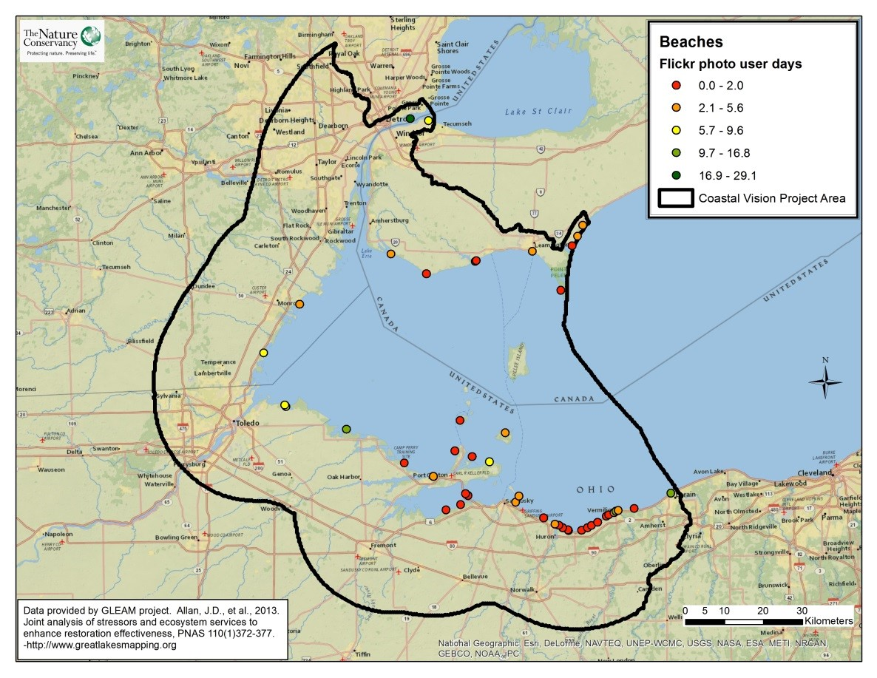
Take Home Points
- Beaches provide opportunities for people to connect with nature and enjoy recreational activities

- Each beach-goer spends about $25 per day; beaches contribute millions annually to the local coastal economy

- The LEBCS survey ranked recreation as the most important service provided to people by Lake Erie

Beaches. Publically accessible beaches are depicted by colored dots. Colors represent the number of flickr photo-user days, which is a proxy for the number of visitors to the beach, with green as the highest density and red as the lowest. The WLEB analysis area is outlined in black.

Public beaches in relation to regional ecological and social values
Beaches provide the public with an opportunity to connect with nature and enjoy activities like swimming, walking and picnicking. Those who visit the beach also tend to visit nearby restaurants, shops and hotels. In this way, beaches also provide indirect benefits to the local coastal economy, in addition to directly benefiting their visitors. A survey of Maumee Bay visitors conducted in 1999 found that visitors spent an average of US$25 per day; given that over a million people visit each year, this beach is estimated to bring in about US$6 million annually¹. A 2010 study in Michigan found that closing a single Michigan beach for even one day could result in a loss ranging from US$130,000 to US$24 million²; a 2001 study estimated that reducing one water quality advisory to all Ohio beaches would provide an aggregate benefit of US$3.2-3.4 million³. There are surprisingly few recent studies on the value of Great Lakes beaches, but the 2010 study of Michigan beaches mentioned above provides a calculated US$56 average per trip value to Lake Erie beaches, which is slightly higher than estimates for beaches on the other three Great Lakes surrounding Michigan⁴. This suggests that Lake Erie beaches are not only still valuable to the local economy, but may actually be worth more than earlier studies, like that of Maumee Bay, have estimated. A survey of 71 stakeholders conducted in 2012 for the Lake Erie Biodiversity Conservation Strategy (LEBCS) found that recreation and tourism was regarded as the most highly valued service provided by Lake Erie and its coastal area⁵. The Public Beaches data layer is included in the Western Lake Erie Coastal Conservation Vision (WLECCV) analysis in recognition of the service that beaches provide to people and to the regional coastal economy.
Related Ecological Layers: Coastal Wetland Restoration

Public Beaches data layer
This layer was developed by the Great Lakes Environmental Assessment and Mapping Project (GLEAM)⁶. The GLEAM project team identified beaches in the Western Lake Erie Basin (WLEB) and attributed them with flickr photo activity as a correlate of potential visitation levels. American beach data was obtained from the U.S. EPA Beaches Environmental Assessment and Coastal Health Act Geospatial database, while Canadian beach data was obtained from Environment Canada; a few additional beaches were identified from the protected lands databases for the U.S. and Canada. The GLEAM project team calculated photo-user days using the Natural Capital Project’s InVEST model (recreation initialization). This model is described in Wood et al (2013)⁷. The GLEAM team used a 500 meter buffer around each beach to capture flickr activity along the shoreline. The result represents the number of annual photo user days, defined as the number of days a unique flickr user uploads at least one photograph within that 500 meter buffer. The total is an average from 2005-2012. Higher photo-user days suggest that these beaches are frequented by the highest number of people. Overall, there are 47 beaches on the WLEB coast including the Detroit River.
Data sources & potential limitations
Data were obtained through personal communication with the GLEAM team.
References & Links
- Sohngen, B., F. Lichtkppler, and M. Bielen. 1999. The value of day trips to Lake Erie beaches. Ohio Sea Grant College Program.
- Song, F., F. Lupi, and M. Kaplowitz. 2010. "Valuing Great Lakes Beaches." Agricultural & Applied Economics Association: 25-27.
- Murray, Chris, Brent Sohngen, and Linwood Pendleton. "Valuing water quality advisories and beach amenities in the Great Lakes." Water Resources Research 37.10 (2001): 2583-2590.
- Song, F., F. Lupi, and M. Kaplowitz. 2010. "Valuing Great Lakes Beaches." Agricultural & Applied Economics Association: 25-27.
- Pearsall, D., et al.. 2012. “Returning to a Healthy Lake: Lake Erie Biodiversity Conservation Strategy.” Technical Report. A joint publication of The Nature Conservancy, Nature Conservancy of Canada, and Michigan Natural Features Inventory. 340 pp. with Appendices. http://www.conservationgateway.org/ConservationByGeography/NorthAmerica/wholesystems/greatlakes/Pages/lakeerie.aspx
- Allan, J.D., et al., 2013. Joint analysis of stressors and ecosystem services to enhance restoration effectiveness, PNAS 110(1)372-377.
http://www.greatlakesmapping.org .
- Wood, S.A., Guerry, A.D., Silver, J.M. & Lacayo, M. 2013. Using social media to quantify nature-based tourism and recreation. Sci. Rep. 3, 2976; DOI:10.1038/srep02976.

Contact
Gust Annis
The Nature Conservancy in Michigan
gannis@tnc.org

