Parks and Recreation Lands
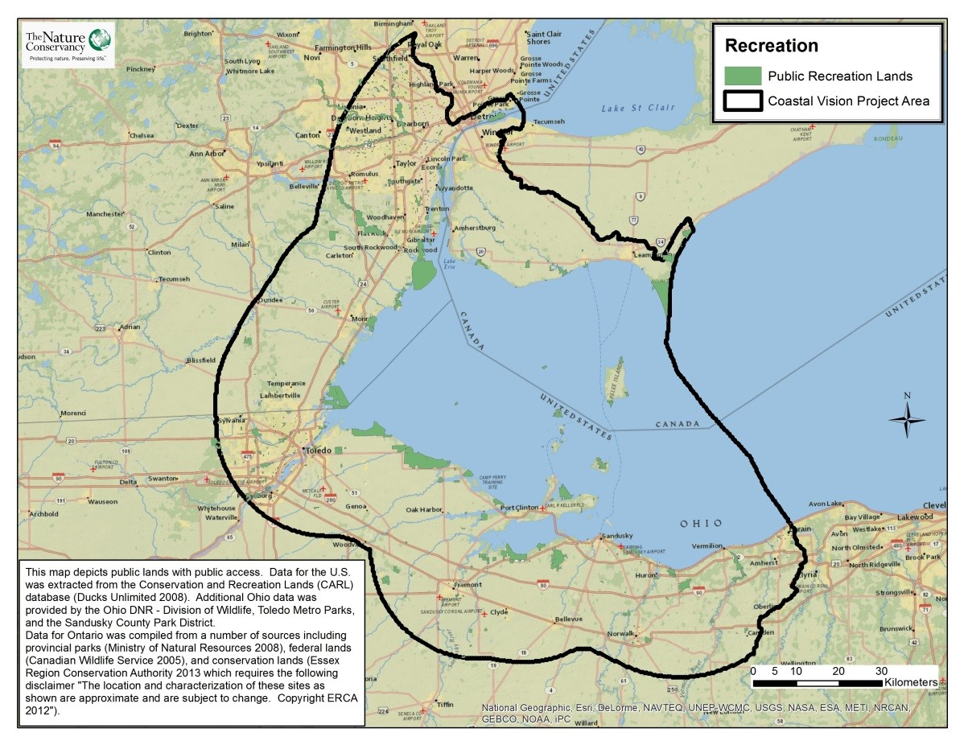
Take Home Points
- Parks contribute to conservation of coastal areas while also providing recreation opportunities that enhance the local economy.

- Access to nature is a critical benefit to residents of the Western Lake Erie Basin, especially in urban areas.

- This map demonstrates regional access to nature through parks and recreational areas
Parks and Recreation Lands. Federal, provincial, state, county, and local parks are shown in green. The WLEB study area is outlined in black.

Parks and recreation lands in relation to regional ecological and social values
Parks and recreational lands serve a variety of purposes, ranging from creating opportunities for recreation, to celebrating historical places, to conserving nature for citizens’ enjoyment and education. Many of these areas contribute to conserving Western Lake Erie coastal areas and provide residents with access to nature, which is a critical benefit in urban areas where the majority of natural land cover has been converted to other uses. A variety of studies relay ways in which people are increasingly disconnected from nature, corresponding to an increase in health problems like obesity and to decreasing happiness and social cohesion among members of society¹. The availability of parks and access to nature is therefore important for the physical and mental health of residents of the Western Lake Erie Basin (WLEB). A survey of 71 local natural resource professionals and conservation practitioners conducted for the Lake Erie Biodiversity Conservation Strategy (LEBCS) revealed that the most important ecosystem service provided by Lake Erie and its coastal area is recreation and tourism². Ohio state parks like East Harbor, Maumee Bay, Marblehead Lighthouse, and several island parks recorded 0.9-1.5 million visitors per park in 2011 alone, indicating the importance of these places to the region’s residents and visitors³. This data layer is included to represent regional access to nature through parks and recreational areas.

Related Ecological layer(s): Migratory Bird Stopover Habitat

Parks and Recreation Lands data layer
This layer includes a total of 1,012 national, state or provincial, county, and local public places and parks that were identified and included in the analysis. Public lands with public access in the United States were obtained from the Conservation and Recreation Lands (CARL) database, which was developed by the Great Lakes-Atlantic Regional Office of Ducks Unlimited. Ontario protected lands were compiled from several sources that collectively include provincial parks, conservation areas, and federal lands. We computed the amount of park and recreation land in each hexagon using an intersect process in GIS.

Data sources & potential limitations
The CARL database is available online (June 2007; accessed February 2008). Additional Ohio data was provided by the Ohio DNR Division of Wildlife, Toledo Metro Parks, and the Sandusky County Park District. The Canadian parks and recreation dataset was obtained through Nature Conservancy of Canada (NCC; personal communication). Data for Ontario provided by NCC was compiled from a number of sources, with provincial parks obtained from the Ministry of Natural Resources (2008) and federal lands from the Canadian Wildlife Service (2005). The Essex Region Conservation Authority provided data directly for conservation lands (received March 2014) and requires the following disclaimer; “The location and characterization of these sites as shown are approximate and are subject to change; Copyright ERCA 2012”.
Potential limitations with this dataset include the fact that not all parks or recreation lands are included in the CARL data or Ontario lands and both the quality and completeness of all data sets used varies across the WLEB.
References & Links
- Smith et.al. 2013. Relating ecosystem services to domains of human well-being: foundation for a U.S. index. Ecological Indicators, 28: 79-90.
- Pearsall, D., et al.. 2012. “Returning to a Healthy Lake: Lake Erie Biodiversity Conservation Strategy.” Technical Report. A joint publication of The Nature Conservancy, Nature Conservancy of Canada, and Michigan Natural Features Inventory. 340 pp. with Appendices. http://www.conservationgateway.org/ConservationByGeography/NorthAmerica/wholesystems/greatlakes/Pages/lakeerie.aspx
- Personal communication with Ohio Department of Natural Resources.

Contact
Gust Annis
The Nature Conservancy in Michigan
gannis@tnc.org

