Surface Water Intakes
Take Home Points
- Lake Erie supplies drinking water to millions of residents in the Western Basin.

- Pollution negatively impacts water provision and purification both ecologically and economically.

- Preserving natural land cover and surface water bodies around intake points helps to filter water, thereby reducing treatment costs.
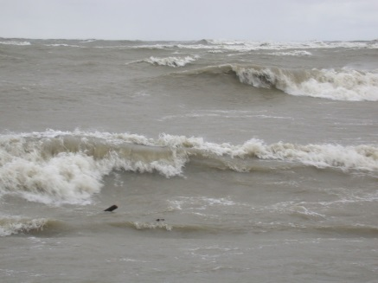
Surface water intakes in relation to regional ecological and social values
People have been withdrawing water from Lake Erie for over 150 years. Millions of Western Lake Erie Basin (WLEB) residents, along with industry, rely on viable infrastructure to access potable water from Lake Erie. In 2011, Lake Erie surface water withdrawals totaled 59 billion gallons per day¹. The provision of water and water purification are two of the top 10 most highly valued ecosystem services provided by Lake Erie and its coastal area, according to a survey of lake managers and conservation practitioners conducted as part of the Lake Erie Biodiversity Conservation Strategy (LEBCS)². We also recognize that these same coastal surface waters provide spiritual and cultural fulfillment for native peoples³. The quality of these valued services is currently threatened by pollution. In 2013, high levels of the toxin microcystin forced a small municipal water intake facility in Carroll Township, Ohio, to close, affecting roughly 2,000 customers⁴. In the same year, the elevated concentration of neurotoxins in the lake forced the city of Toledo to request an additional $1 million (USD) for chemicals to ensure proper treatment of the city’s drinking water⁵. Then, in 2014, microcystin levels exceeded standards for the City of Toledo, which prompted a “do not drink” order forcing roughly 500,000 people to find alternative water sources for two days. Surface water intakes not only give a supply of drinking water to local citizens, but also provide water for other activities, including industrial applications, power generation facilities, and irrigation for agriculture. Protection of water intake locations, and of the water source, can alleviate the negative ecological and economic impacts of pollution by preventing contamination from entering the lake. This is done by preserving natural land cover around intake points, which helps to filter water before it enters intakes, thereby reducing treatment costs. Protecting surface water intake points is a prime example of a conservation strategy that recognizes the intertwined relationship of social values, economic interests, and ecological concerns.
Related Ecological layers: Coastal Wetland Restoration

Surface water intake data layer
This layer includes locations of water intake points on land and in Lake Erie or the Detroit River. For our analysis, we buffered each point by 1 km to represent critical response areas and protected zones, which differ slightly in extent among the three jurisdictions (OH, MI, and ON). Some points in the layer also reflect locations of water treatment facilities. Due to the sensitivity of the water intake points to potential harm, we have agreed not to display maps of the water intake points. To prepare to populate hexes with these points, the Western Lake Erie Coastal Conservation Vision project team created 1km buffers around the U.S. intake points, with the exception of points in the Detroit River, which were only buffered on the upstream side. Canadian intake points already had buffers and these varied slightly depending on where they were. The team then computed the area of these buffers in each hexagon using an intersect process in GIS. When overlapping buffers existed the area was counted each time to emphasize these important areas.
Data sources & potential limitations
Data for Ohio were distributed by the OH Department of Natural Resources (February 2014). The Essex Region Conservation Authority provided data for Ontario (February 2014). Michigan intake points were distributed by the MI Department of Environmental Quality (February 2014; with permission from the Detroit Water and Sewage Department, the City of Monroe Water Plant, and the Water Utility Director for Frenchtown Township).
References & Links
- Great Lakes Commission (2013) Annual Report of the Great Lakes Regional Water Use Database. No. 21, May. Retrieved January 21, 2014 from www.projects.glc.org
- 71 lake managers and conservation practitioners, representing a X percent response to the LEBCS survey.
- Mother Earth Water Walker, accessed 4 November 2014: http://www.motherearthwaterwalk.com/?page_id=11
- Henry, T. (2013, September 15) Carroll Township’s scare with toxin a ‘wake-up call.’ The Toledo Blade. Retrieved January 21, 2014, from www.toldeoblade.com.
- Troy, T. and Henry, T. (2013, September 24) City water plant seeks extra $1M for algae. The Toledo Blade. Retrieved January 21, 2014, from www.toldeoblade.com.

Contact
Gust Annis Doug Pearsall
The Nature Conservancy The Nature Conservancy
gannis@tnc.org dpearsall@tnc.org

http://www.toledoblade.com/watercrisis

