Trails
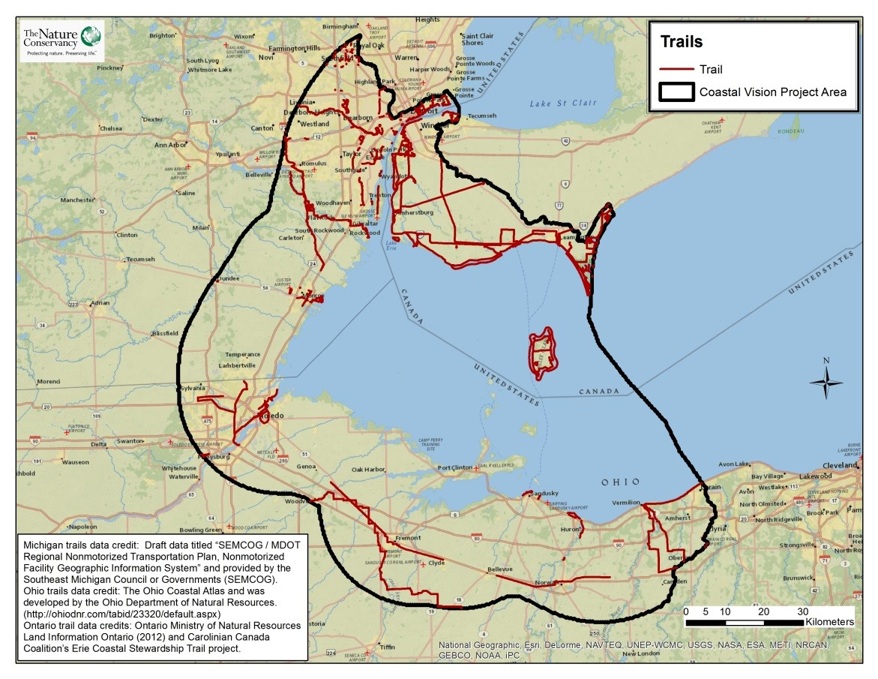
Take Home Points
- There are hundreds of miles of trails in the Western Lake Erie Basin.

- Trails and trail systems provide an opportunity for exercise, socializing, expanding cultural awareness, and connecting with nature.

- Trails have recently become a focus of local and regional planning efforts in order to capitalize on their environmental and physical benefits, as well as on their economic potential.

Trails. Here trails within the WLE watershed and across Ohio are shown in purple. The WLEB analysis area is outlined in black.

Trails in relation to regional ecological and social values
The Western Lake Erie Basin (WLEB) is home to hundreds of miles of trails that are accessible to a wide range of recreational users. Trails benefit human health by providing an excellent opportunity to engage in aerobic activity, contributing to reductions in heart disease, obesity, diabetes, and even hypertension and anxiety¹. In addition to providing an opportunity for exercise, these trails provide economic vitality, access to nature, cultural awareness, and opportunities for socializing. A survey of natural resource professionals and conservation practitioners conducted as part of the Lake Erie Biodiversity Conservation Strategy (LEBCS) revealed that the most important ecosystem service provided by Lake Erie and its coastal area is recreation and tourism². Trails like the Lake Erie Birding Trail facilitate birding and recreational activities that fuel the region’s valuable tourism economy; tourism in Ohio’s seven coastal counties, for example, brings in annual $11.5 billion³. In recent years, trails have become a focus of local and regional planning efforts, not only for social and economic benefits, but also for their important environmental benefits, such as providing habitat for animals and plants and reducing habitat fragmentation by connecting areas of conservation lands⁴. The Michigan Department of Transportation (MDOT) and the Southeast Michigan Council of Governments (SEMCOG) are currently creating regional plans for non-motorized trails that will cover all 7 counties in the region, in recognition of the importance of trails in the well-being of residents. A similar effort is being undertaken in Ontario, which has developed the Ontario Trails Strategy to increase collaboration and access to trails for residents throughout the province. This layer includes trails like the Ohio’s statewide Buckeye Trail, Michigan’s popular Hines Park Bikeway, and Ontario’s 31 mile (50 km) Chrysler Canada Trail and Pelee Island Winery Trail. These trails and others were included in the analysis in recognition of their importance to the people of the WLEB.
Related Ecological Layer(s): Migratory Bird Stopover Habitat

Trails data layer
National, state or provincial, county and local trails that provide public access to nature were considered in the analysis. This data layer includes both existing and planned hiking trails, cycling trails, and trails for both hiking and cycling. This may include features such as shared roadways (roads including bike lanes) or gravel-surfaced trails that may not be suitable for all uses. Approximately 734 miles (1,181 km) of trails were identified within the WLEB for inclusion in the analysis. Trails were attributed to hexes on simple presence-absence basis; no values were assigned to hexes without trails.
Data sources & potential limitations
Trails data for Canada (2012) were produced by the Ontario Ministry of Natural Resources Land Information Ontario⁶ and distributed by Andrea Hebb of Nature Conservancy Canada (received August 2013). Additional Ontario data was provided by Carolinian Canada Coalition’s Erie Coastal Stewardship Trail project and also distributed by Andrea Hebb (received October 2014). Data for Michigan trails was obtained from the Southeast Michigan Council of Governments⁷ (SEMCOG; draft, received 18 Feb 2014), and data for Ohio came from the Ohio Department of Natural Resources⁸ (OH DNR; Dec 2004, received 24 Jun 2013). Both existing and proposed trails were included in the Michigan and Ontario databases. This data layer potentially underrepresents the true number and use of trails within the region because some uses, such as cross-country skiing, were not considered in this analysis due to lack of readily available data. Water trails also were not generally included in this analysis, though some water trails were in the Ontario data.
References & Links
- American Hiking Association (2010) Health Benefits of Hiking. Accessed online on 2/3/2014 via: http://www.americanhiking.org/wpcontent/uploads/2013/04/Heath-Benefits-of-Hiking-fact-sheet.pdf
- Fifty-six lake managers, conservation practitioners, academic and other experts participated in the LEBCS survey.
- http://www.lakeerieimprovement.org/wp-content/uploads/2012/02/leia-strategic-plan-final-12-17-2012.pdf
- Hess, G.A. and Fischer, R.A. (2001) Communicating clearly about conservation corridors. Landscape and Urban Planning. Vol. 55, No. 3, 195-208.
- Downriver Linked Greenway Initiative (2013) Trail Segments. Accessed online on 2/3/2014 via:
http://www.downrivergreenways.org/home/trail-segments
- Accessible online via: http://www.mnr.gov.on.ca/en/Business/LIO/2ColumnSubPage/STEL02_167956.html
- http://www.semcog.org/
- http://www2.ohiodnr.gov/

Contacts
Gust Annis Doug Pearsall
The Nature Conservancy in Michigan The Nature Conservancy in Michigan
gannis@tnc.org dpearsall@tnc.org

