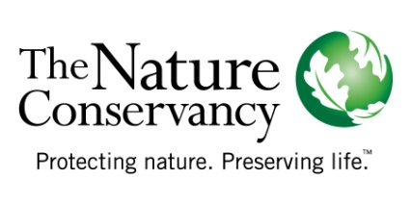
Tools and Templates | Prospective Partner Interview Form  This questionnaire form will help ensure that you are systematic and thorough in your interviews with prospective partners during the scoping step.
Contact information: Name, Address, emails, key staff, tel numbers etc.
Programmatic Expertise
- Mission: What is the prospective partner trying to achieve in the area? Does this overlap with our goals?
- Priority Setting: How does the prospective partner determine what programs and activities to undertake?
- Measures: How does the prospective partner measure results? What have been the results?
- Programs: What are the prospective partner’s major program areas? Does the organization have the technical skills to implement joint projects (single area and multi-area)?
- Portfolio Concurrence: What specific geographic areas is the prospective partner working in, in the relevant ecoregional portfolios?
Legal Status
- Incorporation: Is the prospective partner legally incorporated in the jurisdiction in which it is active?
- Bylaws: Does the organization’s corporate charter allow for partnering and the type of programmatic activities envisioned in a prospective partnership?
- Pending Actions: Is the prospective partner currently involved in any adversarial legal proceeding or have liens against its property/assets?
Organizational Effectiveness
- Board of Directors/Leadership: How are decisions made by the prospective partner? (Board of Directors, a local leader, elected officials, a company with decisions made far away?).
- Strategic Plan: Does the prospective partner have a strategic plan that guides the development of operating plans and activities?
- Financial Management: How does the prospective partner manage its funds? Is there an audit or some type of independent review?
- Financial Resources: What is the prospective partner’s capacity to fund its programs and generate additional funds (fundraising or for profit)?
- Relationships: What other kinds of partnerships has the prospective partner been involved with (number, type of agency/organization, purpose, result, etc.)?
Values
- Values: What are the prospective partner’s key values (science-based, community-based, collaborative, process-driven, results-oriented, etc.) and where is the overlap with the Conservancy’s values?
- Partnership: What are the potential benefits for the prospective partner of working in partnership with the Conservancy versus working alone on its stated mission and goals?

